5th April 2010   
Annual Report to the Trustees

of

ANDY RAY PENSION SCHEME

*Index*

## Introduction

## Tax Return and other disclosures to HMRC & The Regulator

1. HMRC and Regulatory Requirements
2. Pension Rules Changes in 2011
3. Investment and Inflation Yields
4. Pension Schemes Online Service
5. Share of fund split and scheme valuation
6. Benefit Statements

## 

1. Introduction

Pension Practitioner .Com provides administration services to the Trustees and our responsibility is to ensure that the tax exempt privileges of the pension scheme are maintained, provide compliance and administration support.

This report has been prepared to provide you with the following information:

* Disclosures to HMRC and the Pensions Regulator
* A review of the scheme rules in light of legislation in 2011
* An assessment of the scheme yield against inflation for the tax period.
* Provision of member benefits statements
* To draw to the attention of the Trustees any specific matters regarding the scheme’s investments and governance.

## Tax Return and other disclosures to HMRC & The Regulator

The pension scheme return provided to HMRC must end after 6th April 2009 and before 5th April 2010. The accounts therefore relevant for the period are to the year ending 5 April 2010.

Pension Practitioner .Com has submitted the following disclosures:

The employer made gross contributions to the scheme of £130,000. This contribution has been paid in accordance with employer funding requirements and in accordance with the wholly and exclusively for the purposes of trade test.

There were no connected party transactions for the period.

Scheme expenses were less than .05% of the value of the fund

Received bank income was £5515 for the scheme period.

There were no reportable event reports at the date of the return to HMRC

There were no reportable events to the Pensions Regulator at the date of the return

No enquiries at the date of this report have been raised by HMRC or the Regulator.

The account statements showed movement of funds between the scheme and employer, to ensure that this is not viewed as an unauthorised employer payment (and therefore taxable) the trustees must only hold assets in the name of the scheme.

1. HMRC and Regulatory Requirements

HM Revenue & Customs have responsibility for the administration of pension scheme tax reliefs and payments. The Pensions Regulator is concerned with ensuring that member pension benefits are preserved in accordance with the rules of the scheme and that trustees undertake good scheme governance.

The pension scheme’s operation is not regulated by the Financial Services Authority. The reason for this is because the trustees hold and invest money for themselves as beneficiaries of the pension scheme. This does not mean that investments made by the trustees are not covered by the Investors Compensation Scheme. Where funds are lodged with a firm that is regulated by the FSA (or via a passport EEA country) any institutional failure that arises will qualify for a claim through the investors compensation scheme.

Part of our role is to act as agent of the trustees and to ensure that the scheme meets it’s reporting and compliance obligations to the respective regulatory agencies. To ensure that all investments made do not give rise to a tax charge, the trustees must notify us in advance of certain transactions. These can be summarised as:

* Purchase of any unquoted shares
* Property purchase/disposal
* Purchase of goods and materials, such as plant and machinery and other tangibles
* New loans and borrowings, failure to meet current pension loan repayments
* Drawings from the scheme as expenses or otherwise
* Transferring money to other pensions

By giving us advance notice, we will help ensure that taxable transactions are minimised. It should be noted that where the scheme cannot meet a liability for a tax charge, the trustees could be personally liable. Please therefore ensure that we are notified in advance of any activities that fall into the above categories.

1. Pension changes in 2011.

In 2010, a number of changes were proposed for pension schemes, which will come into effect in 2011 and 2012. This part of the report looks at those changes and how you might be affected.

**Annual Allowance**

Each person has an annual allowance which limits the scope of pension contributions that can be made for tax relief deduction. Unlike the previous proposals, you or your business will qualify for tax relief at the marginal rate.

If you do not expect to pay more than £50,000 for 2011/12 onwards, then you will not be affected by the change. If you expect to pay more than this, then you could incur a tax liability on the payment above £50,000.

To ensure that there is not a surge in pension contributions prior to the new contribution limits, anti-forestalling rules have been introduced by HMRC. Not everyone is affected by the anti-forestalling rules and we will take this into consideration in our guidance.

We will give specialist guidance. Please therefore get in touch with us as soon as possible, if you think you might be affected. The closer it gets to 5th April 2011 the more limited we will be on the assistance we can give you.

**Pension Income and Inheritance Tax Changes**

In last year’s emergency Budget on 22 June 2010 and published in the Finance Bill 2010, further changes were proposed to the treatment of inheritance tax. It affects any member who reaches the age of 75 on or after 22 June 2010.

It allows those persons who reach 75 to continue drawing their pension as unsecured income from the scheme up to age 77. This normally allows higher levels of income to be paid than would otherwise be the case where a member at 75 was required to adopt other forms of pension income.

If a member of the pension scheme dies after reaching the age of 77 any of the remaining fund not used to pay either pensions to dependants or a charitable donation, is subject to tax charges up to 70 per cent. We can give specific scheme tax guidance in this area if requested.

**State Pensions**

The method of calculating state pension increase will change. State pension was up-rated by the higher of price inflation or 2.5 per cent. CPI (Consumer Price Index) will be introduced used as a third measure for pension increases from April 2011. The new changes will introduce CPI, and therefore where CPI (it is presently about 3.4%), is greater than earnings or 2.5% the basic state pension will increase by that higher amount. It will not be extended to the earnings related pension/state second pension.

1. Investment Yield

The Consumer Price Index (CPI) is now regarded as the preferred approach to the measurement of inflation; it does this by tracking the changing cost of a fixed basket of goods and services over time. RPI, which is also an inflation measurement index is presently adopted for the cost of indexed linked gilts and other market indices. RPI is therefore more relevant when measuring the cost of pensions in payment and CPI the present and historical measure of inflation.

CPI Inflation for the tax period of 2009/10 was averaged at 3.1%. RPI for the same tax period average at 4.4%. The average yield for this pension scheme over the same tax period is measured by net investment income plus the increase in underlying investments. The net return of scheme assets is less than the bench mark indice but this is due to the fact that the scheme investments were held on short term deposits for the period. The Trustees have since moved funds to Scottish Widows bank which will generate a higher yield. Interest rates are likely to move by .25-.5 basis points which will have a positive effect on deposit returns.

A graph below illustrates the trend of both CPI and RPI.

**Percentage changes**

|  |  |  |  |  |  |  |  |  |  |
| --- | --- | --- | --- | --- | --- | --- | --- | --- | --- |
|  |  |  |  |  |  |  |  | 6 |  |
|  |  |  |  |  |  |  |  | 5 |  |
|  |  |  |  |  |  |  |  | 4 |  |
|  |  |  | **CPI** |  |  |  |  | 3 |  |
|  |  |  |  |  |  |  | 2 |  |
|  |  |  |  |  | **RPI** |  |  |  |
|  |  |  |  |  |  |  | 1 |  |
|  |  |  |  |  |  |  |  |  |
|  |  |  |  |  |  |  |  | 0 |  |
|  |  |  |  |  |  |  |  | -1 |  |
|  |  |  |  |  |  |  |  | -2 |  |
| Nov | Feb | May | Aug | Nov | Feb | May | Aug | Nov |  |
| 2008 |  |  |  | 2009 |  |  |  | 2010 |  |
|  |  |  |  |  |  |  |  |

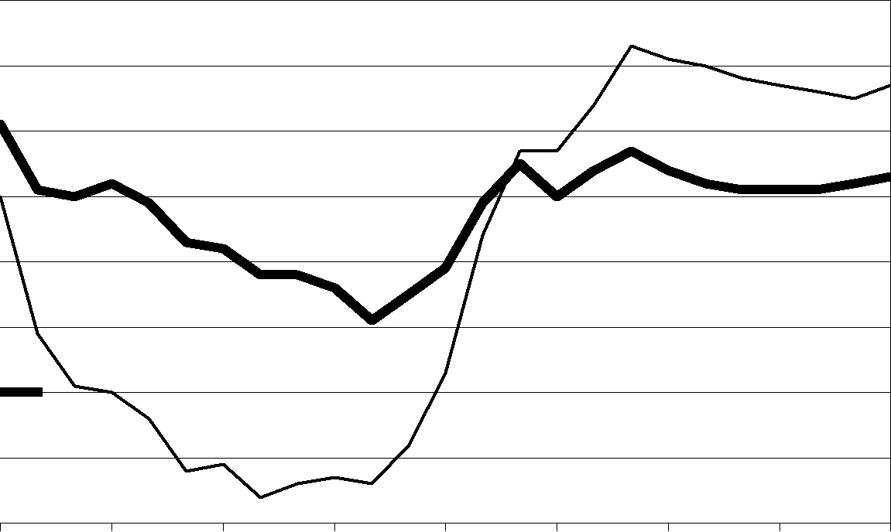

By way of a guide to the industry average, the yield achieved by the average of occupational pension funds for 2009/10 was 13.4% as a bench mark index. This yield is the first positive yield for some time, following a drop of -13.4% in 2008/09 but is reflective of the bench mark index being heavily equity weighted. Next year, we shall be giving a yield comparison against the cumulative average of return of other schemes under our administration.

1. Pension Schemes Online

Since 2008, we have been developing a secure online service for clients to help get the best benefit out of their pension scheme.

The secure online gateway will allow you and your professional advisors a number of innovative solutions that are not offered by any other pension administration company. For example:

* We have updated the pension calculators which were formerly on the Pension Practitioner website to host the most current pension rates in the market and give a greater range of calculation options.
* You can view all of the best pension bank account and building society rates in the UK. You may select the best deals and download the application form direct from the provider. This service is not available through Money Supermarket or any other pension website.
* View all land and property auctions and download the most current listings
* Join our online directory which will allow you to showcase your services through your business to others firms. This will add internet traffic to your business and help you grow. By way of an example, our key domain words are searched 13.500 every month in the UK.

Please feel free to find out more by visiting [www.pensionschemesonline.com](http://www.pensionschemesonline.com) we will be in touch with you shortly on registering for this service. This service is covered by your annual administration fee.

**Retirement Benefits Statement for Andy Ray**

In the event of your death before taking benefits from the scheme, as at 5 April 2010 your beneficiaries will be entitled to receive £395,928 tax free from the assets of the scheme.

In the event that you elected to take benefits from the scheme as at age 65, you could draw a tax-free lump sum of **£123,546; this assumes a total retirement fund of £494,184. The balance of the fund must be used to provide you with a pension which is taxed as earned income. The pension amount you may draw could be £23,256 p.a. This assumes no further pension contributions being paid; it also assumes that there is sufficient cash assets to pay those sums.**

**Notes:**

**The pension income stated is based pension rates as at December 2010, which are not guaranteed to continue.**

**This benefit statement is for illustrative purposes only and is not guaranteed.**

1. **It has been assumed that:**

**Investments increase by 5% p.a. until retirement  
Fund charges are 0.5% of the value of the scheme  
The pension is on a single life basis, non increasing, payable monthly in advance**

1. The figures are costed in today’s terms; this means that inflation is compounded annually at 2.5%. The fund has been discounted back allowing for this inflation rate

If you continue to pay the same contribution rate as that paid in the scheme tax year to age age 65, the lump sum payable could increase to £554.052 and the income in retirement could increase to £104,295. These figures are based on a total pension fund of £2,216,211

Should you require a more detailed calculation specific to your requirements, including a targeted benefits statement for retirement at a future date please contact Pension Practitioner .Com.