*2012 Annual Report to the Trustees of the*

*Ballparkeng Pension Scheme*

*Prepared by:*



*Index*

1. *Introduction*
2. *Pension scheme return*
3. *Inflation report and outlook for 2013*
4. *Economic and markets report*
5. *Newsletter*
6. *Benefits statement*

*1. Introduction*

We are pleased to enclose our annual report to the Trustees.

This report provides a copy of our tax submissions to HM Revenue & Customs on your behalf. Please take the time to review this and advise us of anything that you are not in agreement with.

In addition to this, we have also prepared the following for you.

* Inflation report and outlook for 2013
* Economic and markets report
* A copy of our most recent newsletter
* Provision of member benefit statement(s)

You should also receive our tri-annual newsletter from our pension consultancy team. If you are not receiving this, please let us know.

1. Pension Scheme Return

The pension scheme return provided to HMRC must end after 6th April 2011 and before 5th April 2012.

Pension Practitioner .Com has submitted the following disclosures:

|  |  |
| --- | --- |
| Tax Year ended | 05 Apr 2012 |
| Date submitted | 22 Nov 2012 |
| Submitted by | Pension Practitioner.Com ltd |

Amended Return No

Accounting Period 06 Apr 2011 - 05 Apr 2012

|  |  |
| --- | --- |
| During this period, was the aggregate of payments to and from the scheme greater than £100,000? | No |
| Specify the aggregate of payments to and from the scheme | £90043 |

|  |  |
| --- | --- |
| At the end of this period, did the scheme have assets with a total value before pension liabilities greater than  £400,000? | No |
| Total value of assets before pension liabilities at the end of the period | £247398 |

# Connected Parties

At any time during the period from 06/04/2011 to No 05/04/2012 did the scheme either directly or indirectly

own assets that it had acquired from either:

1. a sponsoring employer or any person connected with that employer?

*or*

1. a person who was a director of or a person connected to a director of a close company that was also a sponsoring employer?

*or*

1. a person who was either a sole owner or partner or a person connected with the sole owner or partner of a business which was a sponsoring employer?

*or*

1. a member or person connected with a member?
2. There were no reportable events arising during the scheme year.
3. There were no tax payments due during the scheme year.
4. No enquiries at the date of this report have been raised by HMRC or the Regulator.
5. If you do not agree with any data in this return please let us know.
6. Inflation Report 2012 and 2013 Outlook

It is important to consider the effects of inflation on pension funds to ascertain any real growth in a pension scheme. Simply put, if your pension fund return over the tax year exceeds that of inflation your fund has grown in real terms and has maintained purchasing power.

CPI and RPI measure change in the prices charged for goods and services bought for consumption in the UK. Prices are recorded monthly for a typical selection of products (referred to as the ‘basket of goods’), using a large sample of shops and other outlets.

From April 2011 the Government has transferred pension increases to the Consumer Price Index (CPI) measure which in the Treasury's own words "...is designed to take account of the fact that consumers tend to shop around, switching to cheaper alternatives when prices of similar goods change." However in doing so pensioners purchasing power diminishes as on average, you might expect CPI inflation to be roughly 0.5% to 0.75% a year below RPI inflation although the gap has widened in the past few years.

CPI inflation stood at 3.5% in March 2012, down from a peak of 5.2% in September 2011. That fall reflected the effects of earlier increases in energy prices and VAT dropping out of the twelve-month inflation rate.

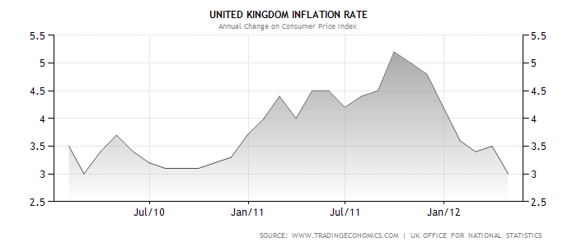

# Short and long term forecast

The near-term outlook is judged to be somewhat lower than expected, with inflation now likely to remain above the 2% target for the next year or so. This revision reflects both the impact of energy prices and indirect taxes, and also a judgment that cost pressures from past rises in commodity prices and weak productivity are likely to have a greater impact on inflation in the near term than expected three months ago. A gradual easing in the impact of external price pressures and a continuing drag from economic slack should cause inflation to fall back to around the target of in the second half of the 2012/13 forecast period.

You will see from the graph below that the forecast for inflation for the year ahead has the greatest probability in the 2.5% to 3% range – hence the darker the red the greater the consensus on where inflation is heading.

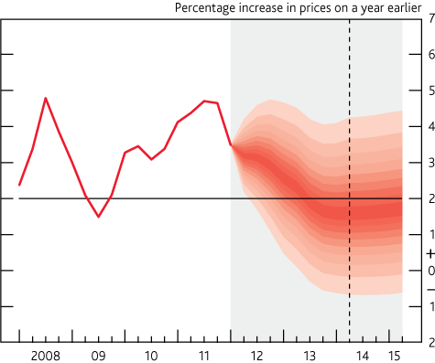

*4. Share performance and economic outlook*

Pension Practitioner has secured the services of an economic research provider to provide a review of the markets in 2011/12 and an assessment for 2012/13.

This outlook is completely independent in its focus and should not in isolation be the basis in which to make a financial decision. The views expressed do not represent the views of Pension Practitioner .Com as we are not regulated to provide financial advice.

The material has been sourced from a number of areas, including the IMF 2012 Outlook report, Goldman Sacks Financial Outlook, and Industry respected individuals such as George Soros and Professor Peter Sheen.

# Stock Market Performance in 2011/12

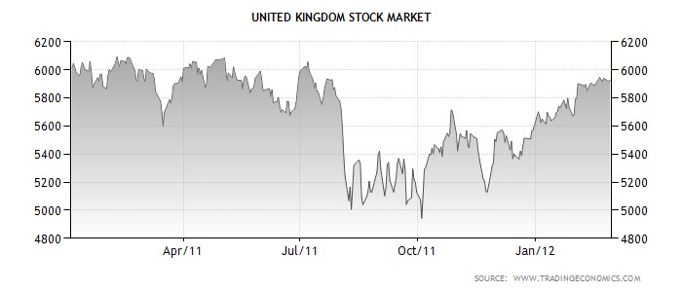

The FTSE 100, which is an index of the 100 largest public listed companies on the London Stock Exchange is also a useful barometer for measuring the state of the country and market confidence. The FTSE hit the dizzy heights of 6900 in January 2000 and since this time it could be said that we are in a persistent bear market. The current market crisis hit the western economies in 2008, any hopeful recovery in stocks prices were short lived. For example, in 2010 the FTSE 100 rose 10%, but lost those gains by early 2012. This pattern has repeated itself in previous years.

Despite this condition, there were some strong performers in 2011; the top four FTSE 100 movers are listed below:

|  |  |  |  |  |
| --- | --- | --- | --- | --- |
| **Name** | **1 Year Chg** | **2 Year Chg** | **3 Year Chg** | **5 Year Chg** |
| Intertek Group | 35.37% | 94.56% | 147.74% | 196.14% |
| Bunzl | 34.80% | 46.69% | 103.52% | 47.31% |
| Rolls-Royce Holdings | 34.73% | 40.03% | 143.96% | 65.15% |
| Next | 34.46% | 48.68% | 99.08% | 44.30% |

# Are UK stocks and shares generally going to go up?

Since 2000, we have had two major corrections, the first trigger was the over-valuation of technology stocks (remember lastminute.com!) and the second most recent a collapse of asset prices. The former was brought about by rising levels of personal debt and a leveraging of assets with an inflated valuation basis.

If you believe history, a third and final correction is due and the same group of economists who forecasted the current market turmoil believe that we are no more than 50% through the current “cycle”. Further corrections could still be due as the collapse in asset prices has still not reduced the level of debt. If you invest in overseas markets, the correction is likely to impinge on growth in emerging markets such as Latin America. To highlight this, the IMF expects growth in Latin America and the Caribbean to moderate to about 3¾% in 2012, from about 4½% last year.

On the contrarian side, stocks look cheap relative to bonds and as the table above shows investment in certain stocks such as Intertek Group would have given you a return on your money of 35% over 12 months to April 2012; money therefore continues to be made in the UK and overseas stock markets but with careful stock selection.

# Are government bonds a safe haven?

The capital markets are the source in which debt is traded and raised by Governments and firms. Countries like Singapore and China who have been buying much of the bonds issued by European banks feel that weaker countries such as Greece, Spain, and Ireland pose a greater default risk and therefore the interest rate that these countries can borrow at increases.

In the short term, “safe” countries such as Germany and to some extent the UK have seen their borrowing rates reduce. UK Government bonds yields are likely to remain low in 2012, despite bank downgrades which also means that pension income rates will stay low. If you are drawing a pension, the yields by which your pension is assessed will remain unchanged at best. UK Government bond yields may however rise if our economy does not start showing some real growth; as there will be a lack of market confidence and questions will arise on debt serviceability.

Pension funds can invest in UK and overseas government bonds through a variety of methods. The most popular method of investing in in UK government bonds is via Post Office bond issues. Members of the public can also buy gilts directly from the Debt Management Office at gilt auctions. Current post office issues give a return of a little over 3% on 1 year investments. Building society bonds which carry a higher risk are yielding an extra 0.5% return on average for 1 year issues.

As bonds are a form of debt, this takes us to commercial borrowing rates. The outlook on commercial borrowing rates for 2012 is that the cost for banks borrowing in the wholesale market will increase – which will be passed on to retail customers, such as trustees of pension schemes purchasing and refinancing commercial property.

Cash returns on deposits remains low, but to assist you and your advisor in finding the best rates for cash, the attached link gives an indication of the typical rates payable for pension accounts. [http://www.investmentsense.co.uk/free-services/best-buy-savings-accounts/accounts-for-](http://www.investmentsense.co.uk/free-services/best-buy-savings-accounts/accounts-for-pensions/) [pensions/](http://www.investmentsense.co.uk/free-services/best-buy-savings-accounts/accounts-for-pensions/)

# Commercial Property

Property is a lagging indicator; as it takes time for prices and market confidence to feed into the property sector. With this in mind, rental yields are expected to continue to fall in 2012 and are unlikely to improve in 2013 but properties in prime location with good covenants will continue to remain firm. There remains an oversupply of commercial units in many areas, and the retail sector will continue to be hard hit. Reduced spending power by consumers is feeding into declining retail prices in most areas.

This is borne by the present yields on property – which are:

|  |  |  |
| --- | --- | --- |
|  | **Initial yield** | **20 Year Average** |
| Retail | 6.0% | 6.3% |
| Office | 6.0% | 7.3% |
| Industrial | 7.1% | 7.9% |

Source: IPD, FT, Property Data. IPD and matching data as at end January 2012.

Pension Schemes Online contains a rolling list of all current and property auctions over the next 6 months; together with property auction results plus direct access to commercial mortgage firms.

1. *Newsletter*

# Double tax-free cash

A QROPS is a registered overseas pension scheme and suits individuals looking to retire out of the UK.

An unintended consequence of the pension regulations however presently exists in allowing two tax free cash lump sums being paid. Quite simply a UK resident can take one sum of tax free cash before they transfer into a QROPS and again after moving their pension back to the UK.

The loophole arises in that the pension administrator for the QROPS does not have to identify incoming “crystallised funds”. When the QROPS is transferred back to the UK, the receiving scheme has no statutory requirement to request whether the transfer back is “crystallised” or not. Therefore the member could take a further 25% of the fund as a lump sum. As odd as this may seem it is a consequence of the constant changes we have seem to pension rules following “simplification”. We expect the Revenue to close this loophole by Spring of 2013.

# Pension Liberation

We have always tried to ensure that trustees avoid pension liberation schemes at all costs. SSAS are regulated by The Pensions Regulator (TPR); who took three firms to Court in connection with the use of pension schemes as a “vehicle” to facilitate loans to members through a series of seemingly unconnected investment firms.

Essentially, you make an investment in one unconnected company through a pension fund, but are entitled to a commercial loan (usually unsecured) through another firm. The funds are simply moved around and you typically get back 85% of your investment as a loan. Even though they are unconnected, one is conditional on the other happening.

The pension scheme can take a host of different forms, but they are aimed for the one thing. To allow you access to your pension before age 50/55. Presently, those individual affected may be subject to a financial sanction.

# Commercial Mortgage Service

We are pleased to announce the launch of a new commercial mortgage service. Approximately 40% of schemes own commercial property and we have agreed terms with RBS/NatWest, Santander, Metro Bank, Barclays, Lloyds TSB for a specialist direct access commercial mortgage product for pension schemes. The product will be low cost, it fits self administered schemes perfectly. If you have an existing commercial mortgage and are seeking to get a better deal, we would be pleased to see if you interest costs can be cut.

This will be available via a revamped Pension Practitioner .Com website which will be available in 2013.

# Pension Loans – Incorrect use of funds

Any use of scheme funds by the trustees in the form of unauthorised expenses or for investment in plant/machinery, unsecured loans or any other form of wasting asset will be taxed.

Pension Practitioner is not a co-signatory of investments and as trustees you are investing and managing money for you as beneficiary(s). All trustees have been provided with a simple fact sheet to adhere to on transactions that will be either taxed or are subject to restrictions under the money laundering regulations; it is important that those principles are adhered to. If your business is in financial difficulty do not look to the pension scheme as a short term cash measure as the long term damage to both your retirement and taxation liability will be painful.

Any loans made to the business must be strictly in accordance with HMRC rules. Approximately 3% of all schemes make unauthorised payments in the scheme year to the business or a connected party which we are required to report to HMRC. To avoid tax penalties, always stick to the rules of the pension scheme – if in doubt ask us.

# Retiring Overseas? Improve your lump sum and options

Gibraltar has paved the way for QROPS to be offered via the State, which also satisfies UK requirements. The main feature of the amendment, is that all benefits paid are to be taxed at a rate of 2.5%.

The legislation also provides for a pension-commencement lump sum, of no more than 30%; a minimum retirement age of 55. It may be lower if in chronic ill health; and it prohibits schemes imported into Gibraltar from being transferred to another scheme outside of Gibraltar "which does not comply with the original requirements" of the Gibraltar scheme.

We would be pleased to answer your questions relating to Gibraltar QROPS. You are recommended to speak with your Financial Advisor on pension transfers from the UK.

1. *Benefits Statement*

# Retirement Benefits Statement for

Andrew Emanuel

In the event of your death before taking benefits from the scheme, as at 5 April 2012 your beneficiaries will be entitled to receive £123,699 tax free from the assets of the scheme.

In the event that you elected to take benefits from the scheme as at age 65, you could draw a tax-free lump sum of £33,446. This is based on a retirement fund of £133,783.

The balance of the fund must be used to provide you with a pension which is taxed as earned income. The pension amount you may draw could be £5972 p.a.

Notes:

The pension income stated is based pension rates as at 5 April 2012, which are not guaranteed to continue.

This benefit statement is for illustrative purposes only and is not guaranteed.

1. It has been assumed that:

Investments increase by seven percent per annum until retirement

Fund charges are half a percent per annum of the value of the scheme fund Employer contribution rate is £5000 p.a. until retirement age

The pension is on a single life basis, non-increasing, payable monthly in advance

1. The figures are costed in today’s terms; this means that inflation is compounded annually at two and a half percent per annum. The income has been discounted back allowing for this inflation rate

Should you require a more detailed calculation specific to your requirements, including a targeted benefits statement for retirement at a future date please contact Pension Practitioner

.Com.

# Retirement Benefits Statement for

Colette Marie Donze

In the event of your death before taking benefits from the scheme, as at 5 April 2012 your beneficiaries will be entitled to receive £123,699 tax free from the assets of the scheme.

In the event that you elected to take benefits from the scheme as at age 70, you could draw a tax-free lump sum of £44,869. This is based on a retirement fund of £179,477.

The balance of the fund must be used to provide you with a pension which is taxed as earned income. The pension amount you may draw could be £8464 p.a.

Notes:

The pension income stated is based pension rates as at 5 April 2012, which are not guaranteed to continue.

This benefit statement is for illustrative purposes only and is not guaranteed.

1. It has been assumed that:

Investments increase by seven percent per annum until retirement

Fund charges are half a percent per annum of the value of the scheme fund Employer contribution rate is £5000 p.a. until retirement age

The pension is on a single life basis, non increasing, payable monthly in advance

1. The figures are costed in today’s terms; this means that inflation is compounded annually at two and a half percent per annum. The income has been discounted back allowing for this inflation rate

Should you require a more detailed calculation specific to your requirements, including a targeted benefits statement for retirement at a future date please contact Pension Practitioner

.Com.