David Evans

11 Brunswick Terrace

The Knoll

Beckenham

BR3 5LL

Hargreaves Lansdown   
One College Square South   
Anchor Road   
Bristol   
BS1 5HL

19th December 2018

**GIS Evans Haig Pension Scheme**

**Mr David Evans**

**HL Client No. 1083808**

Dear Sirs,

Please find enclosed an application to fully transfer my Vantage SIPP, together with:

1. Hargreaves Lansdown Vantage SIPP Transfer Out Form
2. Trust Deed
3. Scheme Rules
4. Scorpion Pension Scam Booklet
5. HMRC Tax Registration Letter
6. HMRC Scheme Open Screenshot
7. HMRC Scheme Administrator Screenshot
8. AIB Scheme bank account statement

I trust that you will find the enclosed complete and please do not hesitate to contact me should you have any further queries.

Yours Faithfully,

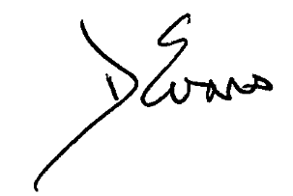

David Evans

Scheme Administrator