Aviva Customer Retirement Centre

PO Box 520

Norwich

NR1 3WG

27th July 2021

Via email and post: pensr70@aviva.com

**Plan: 30773541AR**

**Aviva Personal Pension Plan**

**Plan Holder Name: Mr Stephen Christopher Heath**

To Whom it May Concern,

Further to your letter dated 1st July 2021 addressed to Mr Heath, please accept this letter as confirmation that Stephen Heath wishes to transfer his funds to his pension scheme Joel 2 vs25-27 Pension Scheme, PSTR 20003485RA, tax registered 03/11/2020.

Please find enclosed completed:

1. Request to Transfer form
2. Pension Transfer Out Form
3. HMRC Tax Registration letter

We would be grateful if you may process Stephen’s request at your earliest convenience to his pension scheme bank:

Account Name: Joel 2 vs 25-27 Pension Scheme

Bank: Allied Irish Bank (GB)

Account Number: 04919088

Sort Code: 23-83-96

Should you have any queries, or require any further information, please do not hesitate to contact us.

Yours Faithfully,

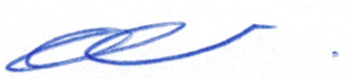

Esther Salmon

Scheme Administrator