***2012 Annual Report to the***

***Trustees of***

**John P Sullivan Pension Scheme**

*Prepared by:*



*Index*

1. *Introduction*
2. *Pension scheme return*
3. *Inflation report and outlook for 2013*
4. Economic and markets report
5. *Newsletter*
6. Benefit Statement

## 

1. Introduction

We are pleased to enclose our annual report to the Trustees.

This report provides a copy of our tax submissions to HM Revenue & Customs on your behalf. Please take the time to review this and advise us of anything that you are not in agreement with.

In addition to this, we have also prepared the following for you.

* Inflation report and outlook for 2013
* Economic and markets report
* A copy of our most recent newsletter

You should also receive our tri-annual newsletter from our pension consultancy team. If you are not receiving this, please let us know.

1. Pension Scheme Return

**Details**

|  |  |  |
| --- | --- | --- |
| Pension Scheme Tax Reference |  | 00763754RA |
| Pension Scheme Name |  | John P Sullivan Pension Scheme |
| Is the scheme an Occupational scheme? |  | Yes |
| Tax Year ended |  | 05 Apr 2012 |
| Date submitted |  | 30 Jul 2012 |
| Submitted by |  | Pension Practitioner.Com ltd |
| Scheme Administrator |  | JPS Pension Ltd |

|  |  |  |
| --- | --- | --- |
| Amended Return |  | No |

|  |  |  |
| --- | --- | --- |
| Accounting Period |  | 06 Apr 2011 - 05 Apr 2012 |

|  |  |  |
| --- | --- | --- |
| During this period, was the aggregate of payments to and from the scheme greater than £100,000? |  | No |
| Specify the aggregate of payments to and from the scheme |  | £48817 |

|  |  |  |
| --- | --- | --- |
| At the end of this period, did the scheme have assets with a total value before pension liabilities greater than £400,000? |  | No |
| Total value of assets before pension liabilities at the end of the period |  | £127623 |

**Connected Parties**

|  |  |  |
| --- | --- | --- |
| At any time during the period from 06/04/2011 to 05/04/2012 did the scheme either directly or indirectly own assets that it had acquired from either: a. a sponsoring employer or any person connected with that employer? *or* b. a person who was a director of or a person connected to a director of a close company that was also a sponsoring employer? *or* c. a person who was either a sole owner or partner or a person connected with the sole owner or partner of a business which was a sponsoring employer? *or* d. a member or person connected with a member? |  | Yes |

**Outstanding Loans**

|  |  |  |
| --- | --- | --- |
| Total amount outstanding at the end of the period |  | £47200 |
| Total amount of any loans made |  | £47200 |
| Total amount of any loans repaid |  | £0 |
| Total amount of interest received |  | £0 |

**Cash and Bank Information**

|  |  |  |
| --- | --- | --- |
| Total amount of all cash and bank balances at the beginning of the period |  | £51806 |
| Total amount of all cash and bank balances at the end of the period |  | £866 |
| Total amount of interest credited to these accounts |  | £0 |

**Arms Length Transactions**

|  |  |  |
| --- | --- | --- |
| Total cost or market value of any assets owned at the end of the period Specify whether this amount is |  | £79557  Cost |

|  |  |  |
| --- | --- | --- |
| Nature of asset(s) acquired |  | Quoted shares |
| Total cost of any assets acquired |  | £49350 |

|  |  |  |
| --- | --- | --- |
| Total amount of income from assets received |  | £0 |

## Inflation Report 2012 and 2013 Outlook

It is important to consider the effects of inflation on pension funds to ascertain any real growth in a pension scheme. Simply put, if your pension fund return over the tax year exceeds that of inflation your fund has grown in real terms and has maintained purchasing power.

CPI and RPI measure change in the prices charged for goods and services bought for consumption in the UK. Prices are recorded monthly for a typical selection of products (referred to as the ‘basket of goods’), using a large sample of shops and other outlets.

From April 2011 the Government has transferred pension increases to the Consumer Price Index (CPI) measure which in the Treasury's own words "...is designed to take account of the fact that consumers tend to shop around, switching to cheaper alternatives when prices of similar goods change." However in doing so pensioners purchasing power diminishes as on average, you might expect CPI inflation to be roughly 0.5% to 0.75% a year below RPI inflation although the gap has widened in the past few years.

CPI inflation stood at 3.5% in March 2012, down from a peak of 5.2% in September 2011.  That fall reflected the effects of earlier increases in energy prices and VAT dropping out of the twelve-month inflation rate.

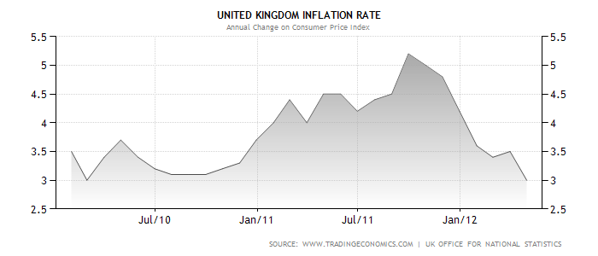

**Short and long term forecast**  
The near-term outlook is judged to be somewhat lower than expected, with inflation now likely to remain above the 2% target for the next year or so.  This revision reflects both the impact of energy prices and indirect taxes, and also a judgment that cost pressures from past rises in commodity prices and weak productivity are likely to have a greater impact on inflation in the near term than expected three months ago.  A gradual easing in the impact of external price pressures and a continuing drag from economic slack should cause inflation to fall back to around the target of in the second half of the 2012/13 forecast period.

You will see from the graph below that the forecast for inflation for the year ahead has the greatest probability in the 2% range – hence the darker the red the greater the consensus on where inflation is heading.

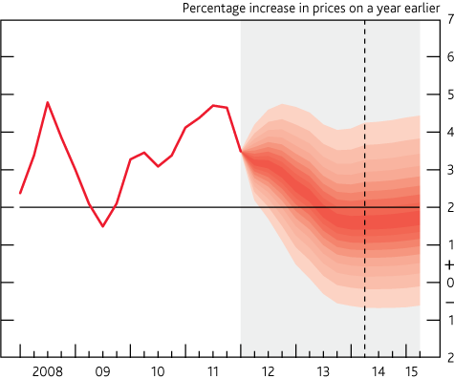

1. Share performance and economic outlook

Pension Practitioner has secured the services of an economic research provider to provide a review of the markets in 2011/12 and an assessment for 2012/13.

This outlook is completely independent in its focus and should not in isolation be the basis in which to make a financial decision. Please refer to your financial advisor for further advice before making any investment decision. The views expressed do not represent the views of Pension Practitioner .Com as we are not regulated to provide financial advice.

The material has been sourced from a number of areas, including the IMF 2012 Outlook report, Goldman Sacks Financial Outlook, and Industry respected individuals such as George Soros and Professor Peter Sheen.

**Stock Market Performance in 2011/12**

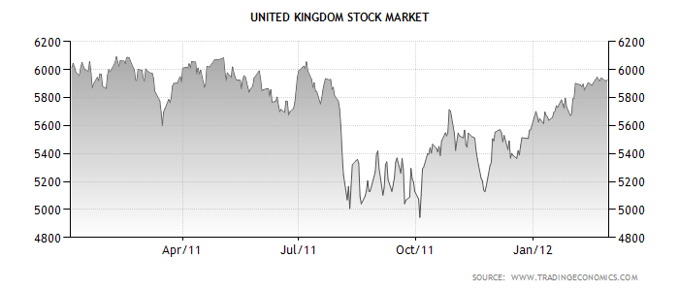

The FTSE 100, which is an index of the 100 largest public listed companies on the London Stock Exchange is also a useful barometer for measuring the state of the country and market confidence. The FTSE hit the dizzy heights of 6900 in January 2000 and since this time it could be said that we are in a persistent bear market. The current market crisis hit the western economies in 2008, any hopeful recovery in stocks prices were short lived. For example, in 2010 the FTSE 100 rose 10%, but lost those gains by early 2012. This pattern has repeated itself in previous years.

Despite this condition, there were some strong performers in 2011; the top four FTSE 100 movers are listed below:

|  |  |  |  |  |
| --- | --- | --- | --- | --- |
| Top of Form  Bottom of Form  [**Name**](javascript:document['form_C0'].submit();) | Top of Form  Bottom of Form  **Description: reverse the order**[**1 Year Chg**](javascript:document['form_C8'].submit();) | Top of Form  Bottom of Form  [**2 Year Chg**](javascript:document['form_C9'].submit();) | Top of Form  Bottom of Form  [**3 Year Chg**](javascript:document['form_C10'].submit();) | Top of Form  Bottom of Form  [**5 Year Chg**](javascript:document['form_C11'].submit();) |
| Intertek Group | 35.37% | 94.56% | 147.74% | 196.14% |
| Bunzl | 34.80% | 46.69% | 103.52% | 47.31% |
| Rolls-Royce Holdings | 34.73% | 40.03% | 143.96% | 65.15% |
| Next | 34.46% | 48.68% | 99.08% | 44.30% |

**Are UK stocks and shares generally going to go up?**

Since 2000, we have had two major corrections, the first trigger was the over-valuation of technology stocks (remember lastminute.com!) and the second most recent a collapse of asset prices. The former was brought about by rising levels of personal debt and a leveraging of assets with an inflated valuation basis.

If you believe history, a third and final correction is due and the same group of economists who forecasted the current market turmoil believe that we are no more than 50% through the current “cycle”. Further corrections could still be due as the collapse in asset prices has still not reduced the level of debt. If you invest in overseas markets, the correction is likely to impinge on growth in emerging markets such as Latin America. To highlight this, the IMF expects growth in Latin America and the Caribbean to moderate to about 3¾% in 2012, from about 4½% last year.

On the contrarian side, stocks look cheap relative to bonds and as the table above shows investment in certain stocks such as Intertek Group would have given you a return on your money of 35% over 12 months to April 2012; money therefore continues to be made in the UK and overseas stock markets but with careful stock selection.

**Are government bonds a safe haven?**

The capital markets are the source in which debt is traded and raised by Governments and firms. Countries like Singapore and China who have been buying much of the bonds issued by European banks feel that weaker countries such as Greece, Spain, and Ireland pose a greater default risk and therefore the interest rate that these countries can borrow at increases.

In the short term, “safe” countries such as Germany and to some extent the UK have seen their borrowing rates reduce. UK Government bonds yields are likely to remain low in 2012, despite bank downgrades which also means that pension income rates will stay low. If you are drawing a pension, the yields by which your pension is assessed will remain unchanged at best. UK Government bond yields may however rise if our economy does not start showing some real growth; as there will be a lack of market confidence and questions will arise on debt serviceability.

Pension funds can invest in UK and overseas government bonds through a variety of methods. The most popular method of investing in UK government bonds is via Post Office bond issues. Members of the public can also buy gilts directly from the Debt Management Office at gilt auctions. Current post office issues give a return of a little over 3% on 1 year investments. Building society bonds which carry a higher risk are yielding an extra 0.5% return on average for 1 year issues.

As bonds are a form of debt, this takes us to commercial borrowing rates. The outlook on commercial borrowing rates for 2012 is that the cost for banks borrowing in the wholesale market will increase – which will be passed on to retail customers, such as trustees of pension schemes purchasing and refinancing commercial property.

We use Investec Bank for pension scheme bank accounts, who give one of the strongest for returns on cash deposits for terms accounts.

**Commercial Property**

Property is a lagging indicator; as it takes time for prices and market confidence to feed into the property sector. With this in mind, rental yields are expected to continue to fall in 2012 and are unlikely to improve in 2013 but properties in prime location with good covenants will continue to remain firm. There remains an oversupply of commercial units in many areas, and the retail sector will continue to be hard hit. Reduced spending power by consumers is feeding into declining retail prices in most areas.

This is borne by the present yields on property – which are:

**Initial yield 20 Year Average**

Retail 6.0% 6.3%

Office 6.0% 7.3%

Industrial 7.1% 7.9%

Source: IPD, FT, Property Data. IPD and matching data as at end January 2012.

Pension Schemes Online contains a rolling list of all current and property auctions over the next 6 months; together with property auction results plus direct access to commercial mortgage firms. The website is being finalised and will be available shortly

1. Newsletter

A SSAS is a powerful tax planning tool which can be used alongside your company to help save thousands of pounds in tax.

Pension Practitioner.Com not only administers pension schemes but we also undertake a variety of special projects which we can tailor to your needs. The following are examples of bespoke work carried out for clients that could potentially also help you and your business too:

* We have drafted documents ensuring large employer pension contributions above the annual allowance of £50,000 receive tax relief.
* If an individual or business owns an asset, it may be contributed into the pension scheme and tax relief can be obtained on the payment. These contributions are classed as in-specie transfers. For example, a company may transfer part or all of a commercial property (even a mortgaged premises) to your SSAS and may receive corporation tax relief on the transfer. This solution is a very tax efficient way of contributing into a pension scheme, whilst keeping cash in the business.
* Set up staff pension schemes (full occupational pension schemes) where there are more than 11 employees. A SSAS is limited to 11 members so alternative arrangements have to be considered with more than this number.
* Unique scheme rules and configured amendments to trust documents depending on our client requirements.
* Investment in copyright/trademarks and other intellectual property. Provided that the intellectual property does not have a predictive lifespan of less than 51 years, it may be an acceptable investment by the SSAS. For instance, a royalty licence can be transferred or purchased by the SSAS from your company with any future royalty payments reducing your business corporation tax bill.

1. Benefits Statement

**Retirement Benefits Statement for**

**Mr John Sullivan**  
  
In the event of your death before taking benefits from the scheme, as at 5 April 2012 your beneficiaries will be entitled to receive £127,623 tax free from the assets of the scheme.

In the event that you elected to take benefits from the scheme as at age 65, you could draw a

tax-free lump sum of **£86,691.**

**The balance of the fund must be used to provide you with a pension which is taxed as earned income. The pension amount you may draw could be £15,480 p.a.**

**Tax free lump sum and pension income values are based on a future retirement fund of £346,765.**

**Notes:**

**The pension income stated is based pension rates as at 5 April 2012, which are not guaranteed to continue.**

**This benefit statement is for illustrative purposes only and is not guaranteed.**

**In accordance with Statutory Money Purchase Illustration requirements, it has been assumed that:**

|  |  |
| --- | --- |
| Annuity yield | 0.033 |
| Accumulation Rate | 0.05 |
| Expenses Before Retirement | 0.01 |
| Expenses After Retirement | 0.04 |
| Rate of increase in Salary | 0.025 |
| RPI | 0.025 |
|  |  |

We have assumed that 10% of total earnings stated in the event questionnaire are contributed to the Scheme. Where no earnings have been disclosed, we have assumed an annual pay of £50,000.

Should you require a more detailed calculation specific to your requirements, including a targeted benefits statement for retirement at a future date please contact Pension Practitioner .Com.