PORTFOLIO MANAGEMJliNT
7 FUND OPE.'.'lING

Please note that ALL Funds op be managed on a DISCRETION indicated otherwise in Section
ed below will

RY basis unless
.1.

Please tick one Investment Ob Risk Profile for your Fund. Pie Section blank.
ctive and one
e do not leave this

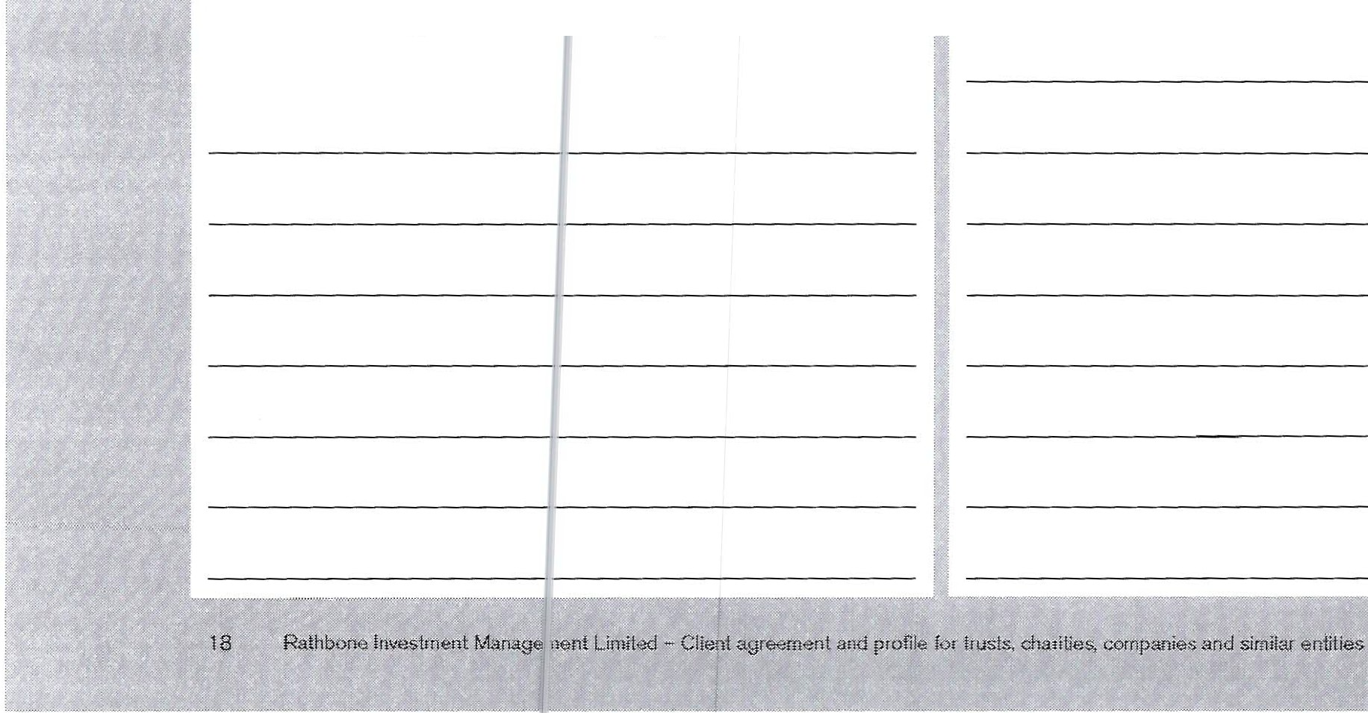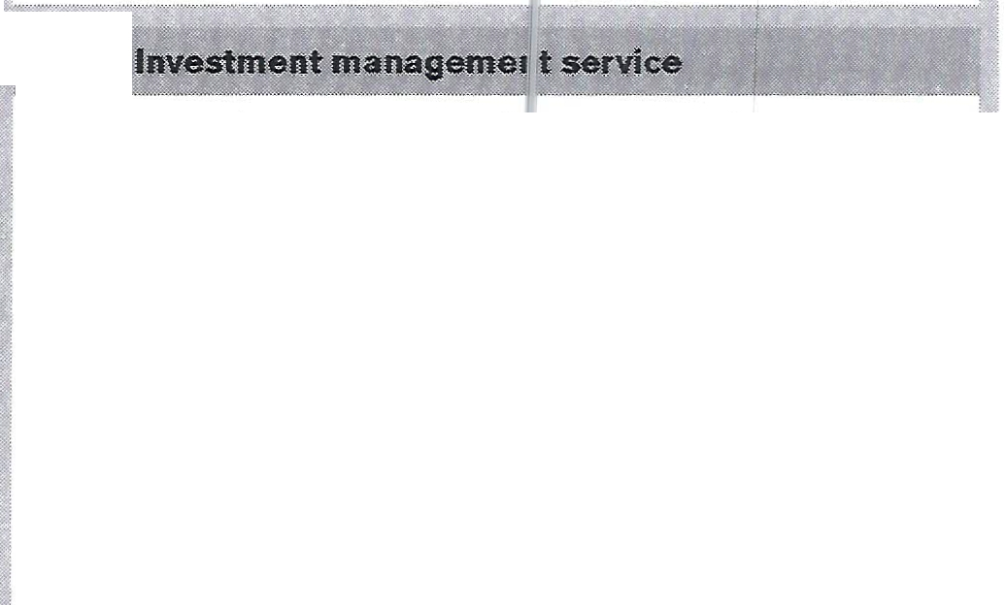Investment Obj ective

Capital growth priority

Balanced between capital rowth and income
Income priority

Risk Profile

Lower
D Medium
D Higher
11
Our preferred approach to work ing with our clients is to provide a discretionary investme nt management service whereby your Investment Mana!er takes responsibility for making all of the decisions abo t the investments in your Portfolio at their discretion, bas id on your requirements .
If you require the Fund request :d above to be managed
on a non-discretionary basis, pli:oase refer to Section 3 - Non-discretionary investment }1anagement service in the
Terms of Business and discuss this with your Investment Manager before confirming the details below.
Additiona l main Funds may Je requested beyond that which has already been select :d above (for example , 'B' Funds) . For each additional Fu id, the fo'. lowing information is required: how the Fund(s) w II be managed (discretionary or non-discretionary) , the l nveJtment Objective, Risk Profile and purpose. This should also oe discussed with your
Investment Manager before cc nfirming the details below.

PO.ttTfOLIO MANAOBMENT
8 PORTFOLI<) INCOME

Please complete
In thllii SectiiQn you have the opp.or unity to decide what you would like one with income 9emarn:ted wltninyour Portf;;ilio, You may ;;;hoose f<:;,ir itto oe retained in your Portfolio for subsequent reinvestrr ent or have tt paid out periodicatlx either wholly or as a fl ;ed amount.

If you require:
- all oi the lneome generated to e etained fer retnvestment; please tlek 1he f1 $fain for reinvestment box;
- all of the Income generated to e p;i!id out monthly or quarterly, pleE\lle tick the AIJ ;, •9ome box and tlck
Monthly or Cluatterfy as appropr ate;
- a fixed amount tQ be id out 1 1onthly or qwafter!y, please enter the val\,le t-O be pa d ott in the Fixed amount box .m.d tl;:;k Monthly or Ouarre1)'. Q.s appropr!.

 | l :etain for  r itinvestrnent |  |   All income Fixed amount |  | Monthly | Period  Quarterly
 |  |  | D | £ | D | D
If yoo rulre a fixe<;i amo1,1nt to Qe j aid out and itm1,1ffici<mt income is generated by ihe f'tJnd d<1rin91hi; period,a capital wilharawal will need to take pf ace.
2 If you choQse to have income pajd < ut ple select how regularly
thi$ should occur by tiaking th¢ Moi thly or Orly boxes as appropriate.

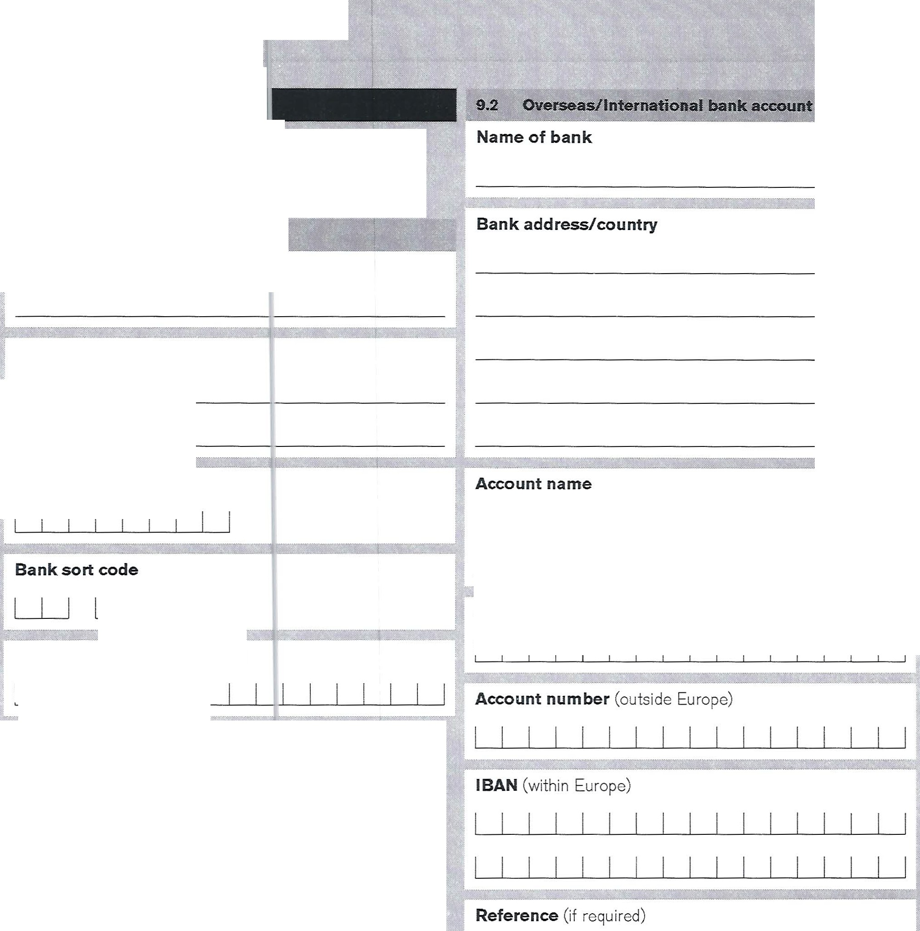

PORTFOLIO ADMlNIST J tATlON

9 BAN K DETJ\I LS

Please complete
..
Please provide appr¢lp. ri<!de ban.k· de;. ails so thaipayments cari be me,de to you. If you prefer to have payrnenfs made to an Gverseas bank acco\Jnt pl,aas<. provide details ln Sedlon 9.2.
9,1 'Simk ac:count

Name of bank or building socie1 ty

Account name

Bank account number

LU LU SWIFTBIC/Bank code Building society roll number



PORTFOLIO ADMINlS1'RATI©N

10 CONN ECl' E D PERs ONS

Please complete where approp
ate.
Solicitor Company name

Accountant Company name
Title
D Mr
D Ms

Surname
D Mrs

D Miss D Other (please spec ify)

Title
D Mr
D Ms

Surname
D Mrs

D Miss D 0th r (please spec ify)

Forename(s)

Address

Forename(s)

Address

Postcode

Telephone
,,

Postcode

Telephone

Email
Email

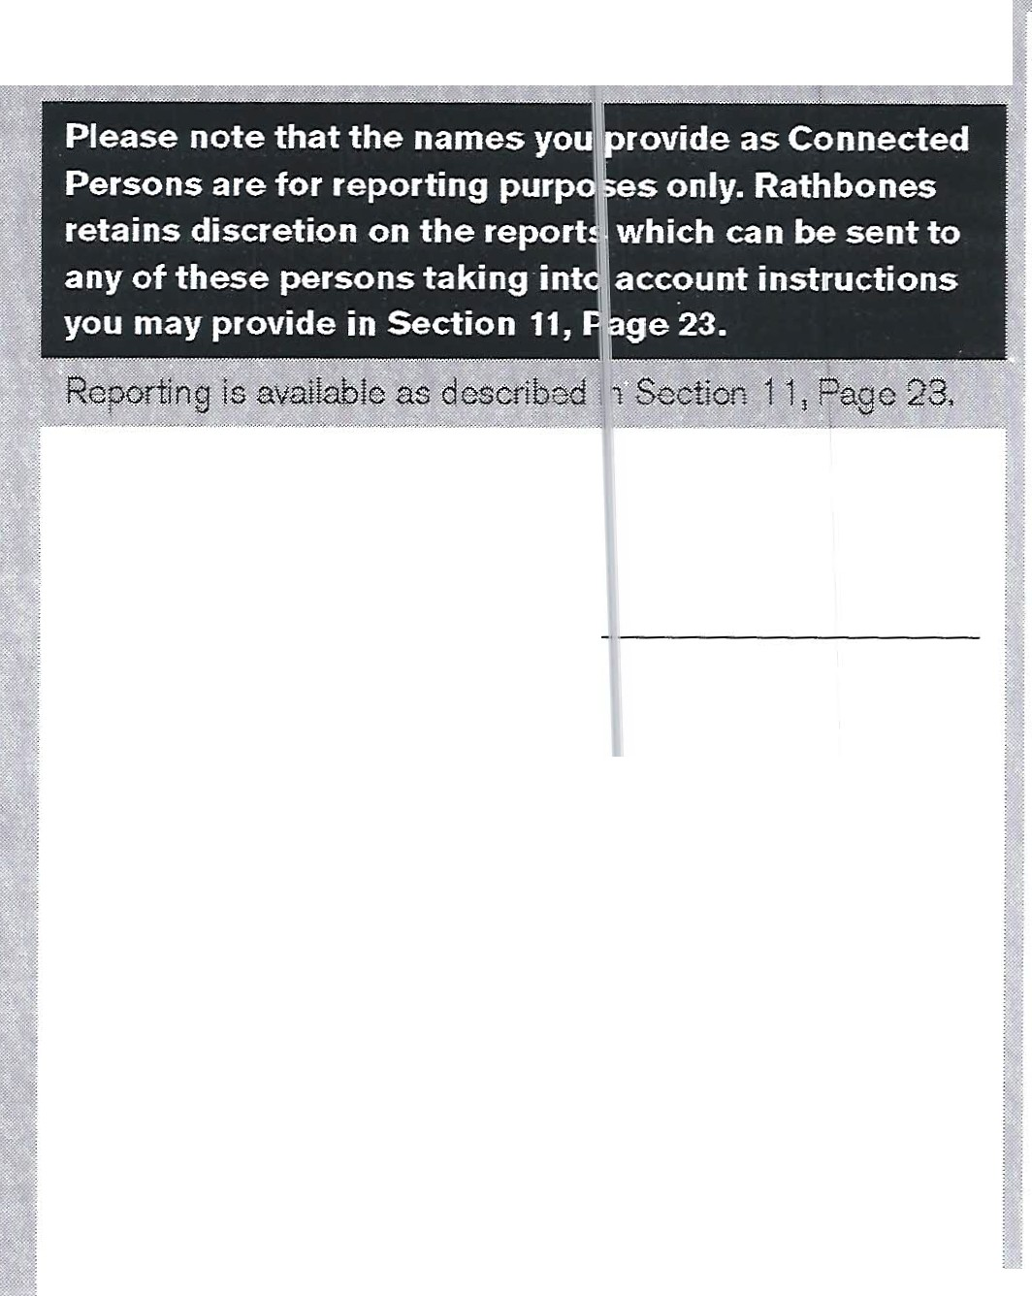



PORTFOLIO ADMINISTJ TION
10 CONNE CTE D PE RS ONS CONTI NUED

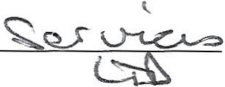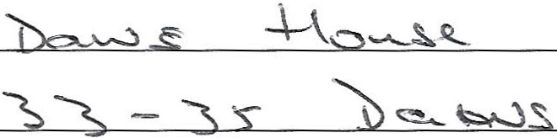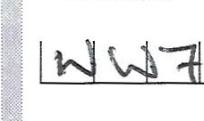Please complete where appropr

Financial Adviser/lntermedia111 Company name

Title
Other Connected Person Relationship

Company name (if applicabl e)
I
,

, \ QO\Lg_ ?Qs-i. , '"'

D Mr
D Ms
D Mrs
D Miss D Ot 1er (please specify)

Title
Mr D Mrs
D Miss

D Other (please specify)

Surname

Forename(s)
I
Address

Postcode

Surname
M c C \<n

Forename(s) l

Address

' -------------------
- ' Postcode

Telephone

Email

Telephone
- I : ; l ol '?d L.il l-l .
bl
Email
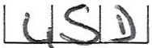
d 1 1 \:)IJ..± lj I J

'- '""Jo fLJ '<A p ac;:.,.
s;:o CV "'-:'C' ,_..... .,. c_ 1 \..A._ \C._

If there are additional Connected Persons, please enter the details in the Oient notes Section on Page 24.


22 RalhboM lnvesiment ManagemM! jJllitii"d - Client agreement 11nd profile for iriJ$!$, cha1lti?$, companies Md similar entities

- ·- - --

PO&TPOUO ADMINISill tATION
11 RE PORTIN1::J

Please complete For all clients

Periodit: reports are available to clle 1ts and Connected
Persons ted formAt and/or or' line, We ask yyu to

indicate which fndividua!$ho1 Id recelve which
reporting option.

ected Person selects r than the printed
Please note that, if you or a Con
the Online Portfolio Service rat
options, a valid emailaddress m
Sectio |  | s 4 and/or 10.

st be provided in
n
Online |  | Online Portfolio | Printed Taxation
P<lrffoli<>  service | Printed | Taxation | pers1  (tick one | Atlnvai  Regulatory | comra:et
valuations | valuations | Papers1 | box. on y) | Report' | note$3
D | D | D | D | D | D
D | D | D | D | D | D

Trustee/Director 1

Trustee/Director 2

Trustee/Director 3

-
'
- | Financial Adviser/Intermedi ary  -•-·'"-- -Wi:<. ""-'----- , | D | D | w.- -,-xw;i'  ·-""' | D  ·'f''

Other Connected Person

tion tfeque
Please tick one of the following frequently valuations are to be r

••<<w)
D | D |  | D |  | D | D
D | D |  | D |  | D | D | D
 |  |  |  |  | D | D | D
D |  |  | D |  | D | D | D  , ,- .... "f'-.-•·-·--,,,.,.,... --

oxes to indicate how eived 4 •

Please note that printed Taxalion Papers will not he sent if you have seletted the OnUne Portfolio Ser11ce option. Printed Trulation Papers will
-
only be S?lt fq one redph;,nt either an authorised offic as listed i.n
Section 4 or a professional adviser,so please tick on!y one of the printed
laxatiqn Papers bo.xe$.

D Six monthly - March and Sep :ember
D Six monthly - April and Septem ber Six monthly - June and Dece nber
D Three monthly
2 By defa'-dt the Annual Regulatol)I Report will Ilesent only to iliJ
authorised officer as Wsted in Section 4.
3 For discrefonary Fun<ls, by default, individual contract notes will not be provided. Detail$ of all contract notes will be int!ud@d in the <l!'llmand printed valuations. However, if individual contr&Gt notes are required as well,please place ticks rn lhis column tQ indicate who should receive Jhem and these will be provided in a timely manner. Should you spe\:liticaily require dispatch on a T'f' 1 baS!s, please coht<;!ct your Investment Manager, For all ()ther Funds, these will be sent I.I;> the Fund hold611
4 Unless <J!heMise stated this will default to six monthly-31 March and 30 September for charities and six morrthly - 5 Apriland 30 mber for trus'U.i, companies and similar entiti1'\S.



12 CLI ENT N ()TES

Please attach additional shee specify the number of sheets i
as necessary and the box below.



If additional sheets have been used please specify the number.

Please ensure that all copies p clearly legible.
vided are


Please provide an origina l or certified copy of the following documents. Not applicable to

This page does not apply to Ba e Trusts except for
footnote 1 below.
Please note that a minimum of tv" o trustees, directors or other authorised officeFs must slg '1 this document for it to be valld. They must be listed in 8G' ction 4 and must provide identity verification documents as per this Section.
Please note that the Information 1mvided below applies to UK clients only tand is not com )rehensive.
For overseas clients and UK cller ts unable to povide the verifk:atlon do\:lllments listed :iefow, your lrwestmen1 Manager will bl)! pleased to exp!a n what is required.

1J,1 GQttin9r tfOQJ!fle
We are required to verify the ider tHy and addrs of every prospective dienti both ind vfdua!s and entities, by obtaJninQ suitable certified docur ients.Certification may be performed either by a Rathbo 1es staff rnerner or a third party as follows:

R.athbones certifie&1ti11>n
You can bring the apf'Jropri ate or 9ina cloeuments
(see below) wih you to a mtlleiln g with your lnvestm1?nt Managet who will take a copy of the orf9inal? and
c ·· mplete the certification proce s for you.
Third party cett!flcation
If you pr$fer, cedif!ca1fon can be performed by a professk:lna.1 who Is governed by antHnoney laundering ret;iulations such as an a.ccounfa114 banker, financial a0¥iser, postmaster or solicitor. They wiif need to view the original document Mcl writs the fo!lowl g words on a copy of
each document to be certified:
•1 ®rtity that this is a compt te and true ®PY of the original document Whid • Ihave seen!
The profesSlonaJ should then s!! n underneath the words they have written and also writ'1 their n$.me, the date they signed and the name and addre,ss of the company they work for.

Please provide an origina l > r certified copy of the following documents.
- Copy of minutes appointing Fi athbones as inve stment manager

The following document is equired w hen not all of the trustees/directors are !1 igning the form.
- Copy of resolution confirmin J ful l authority of signator ies to sign on behalf of the apply ing entity (for trusts and charitable trusts this should ·>e signed by a quorum
of trustees)

company agreements.

  - Trust deed

  - Trust investment policy statement2

  - Trust accounts or latest financial statements (if applicable)

  - Details of additional trustees

  - All deeds of appointment and retirement of all trustees not mentioned in the original tru st deed

13,4 69

Please provide an original or certified copy of the fo llowing documents. Not applicable to trust agreements.
  - Copy of certificate of incorporation

  - Memorandu m and articles of association

  - Latest financial stateme nts Details of additional directors

None of the above documents are required. Instead please provide the following.
  - Trade union rules book
If the charity is governed by a trust deed, please refer
to Section 13.3 above. If the charity is registered with Compan ies House, please refer to Section 13.4 above.
1 if this agreement is for a e Trust and there is $. irust daed
avail!llb!e,We ask tha.t yqu provide it
2 Current UK legislation (the li'usteeAct 2000) im'lp.bses a requin;ment on in.!stees to ti;,ve in pl<i:co a policy spt<;inent providing guidance l.o Investment Managers whfdi we request that you provido.



For EACH individual listed in Section 4 who will be providing instructions on the Portfolio, please verify their identity by providing ON E of the following.
Either the original to be certi1 'ied by Rathbones or a copy certified by a third party .
- Current passport
- Current full UK driving licence 1
HM RC tax notification2
- Govern ment based correspon dence3

For company agreements only, please provide one address verification document from the following list for all shareholders with a shareholding of 25% or more (10% or more for non UK based):
- Recent utility or council tax bill4
- Current full U K driving l icence 1
- Bank, building society, credit union statement / pass book5

For trust agreements only, please provide one address

verification document from the following list for all
named beneficiaries of trust income (not relevant for

For UK based company agreements only, please
provide one identification veri• 'ication document from the following list for all s1 hareholders with a shareholding of 25% or more 10% or more for non UK based):
- Current passport
- Current full UK driving licence
- HMRC tax notification 2
- Governm ent based correspon dence3

charitable trusts):

- Recent utility or council tax bill4
- Current full U K d riving liccncc 1
- Bank, building society, credit union statement/pas sbook5

Each individual listed in Section 4 who has NOT met

""""""""'
,,,,.,,,.,,,,...,.,,.,=
· "' ¥ """"'6% .S *'

their Investment Manager prior to opening their

For trust agreements only, pie ase provide one identification verification d0C1Jment from the following list for all named bE' neficiaries of trust income (not relevant for char i table trusts) :
- Current passport

- Current f ull UK driving licence 1
- HM RC tax notification2

For EACH individual listed in Section 4 who will be providing instructions on t e Portfolio, please verify their address by providing ()NE of the following.
Either the original to be ce1 ified by Rathbones or a copy certified by a third p i rty. Please note that
documents used to verify io entity may NOT also be used to verify address.
Recent utility or council tax b 114
- Cur rent full UK driving liceno;;1

- Bank, building society, credit un ion statement/passbook 5
- @ ::: :::t.:- - , :::

Portfolio AND who will be providing instructions on the Portfolio should also provide ONE ADDITIONAL document from the following. Either the original to
; be certified by Rathbones or a copy certified by a third party.
- Personal portfolio statement from a UK investment manager (not older than 3 months)
- Bank, building society, credit union stat ement/ passbook, (not olde r than 3 months). Credit card statements are

18.10 tff.in OK resident trust befiefk:iari:es
Plsc: pvlde the fo!lowjng
- /\ certified copy of either a non UK resident life tenant's passport or document, which includes an overseas
Tax Identification Number (TIN)

Either the UK phcioco.rd licence or a current full old sty:-e paper licence. The paper cwnterpart of the photocard lic;:enc;:e is not acc<;;pti:®le.Old style provisional li¢ei'ie$ are also Mt aueeptable.
' 2 Nohlder than 12 mo'.lths,
- \.\!Ith relevant reference details eg dafo of birth or Nil.tic lnsurart<!e numbet,

- Not older than 3 months for ui llil;f bills (mebile telephone bills are not acceptable),The !oQal authorily council tax bill must be for the current year,
5 Not older 'than 3 months \credit card statnts not acceptable). 6 Plea&e note that if thls proof h<ts ;¥ready been us lo
verify the clienfs address then ilmay NOT also be used as
adorl:lonal vetlfka:llon, ·

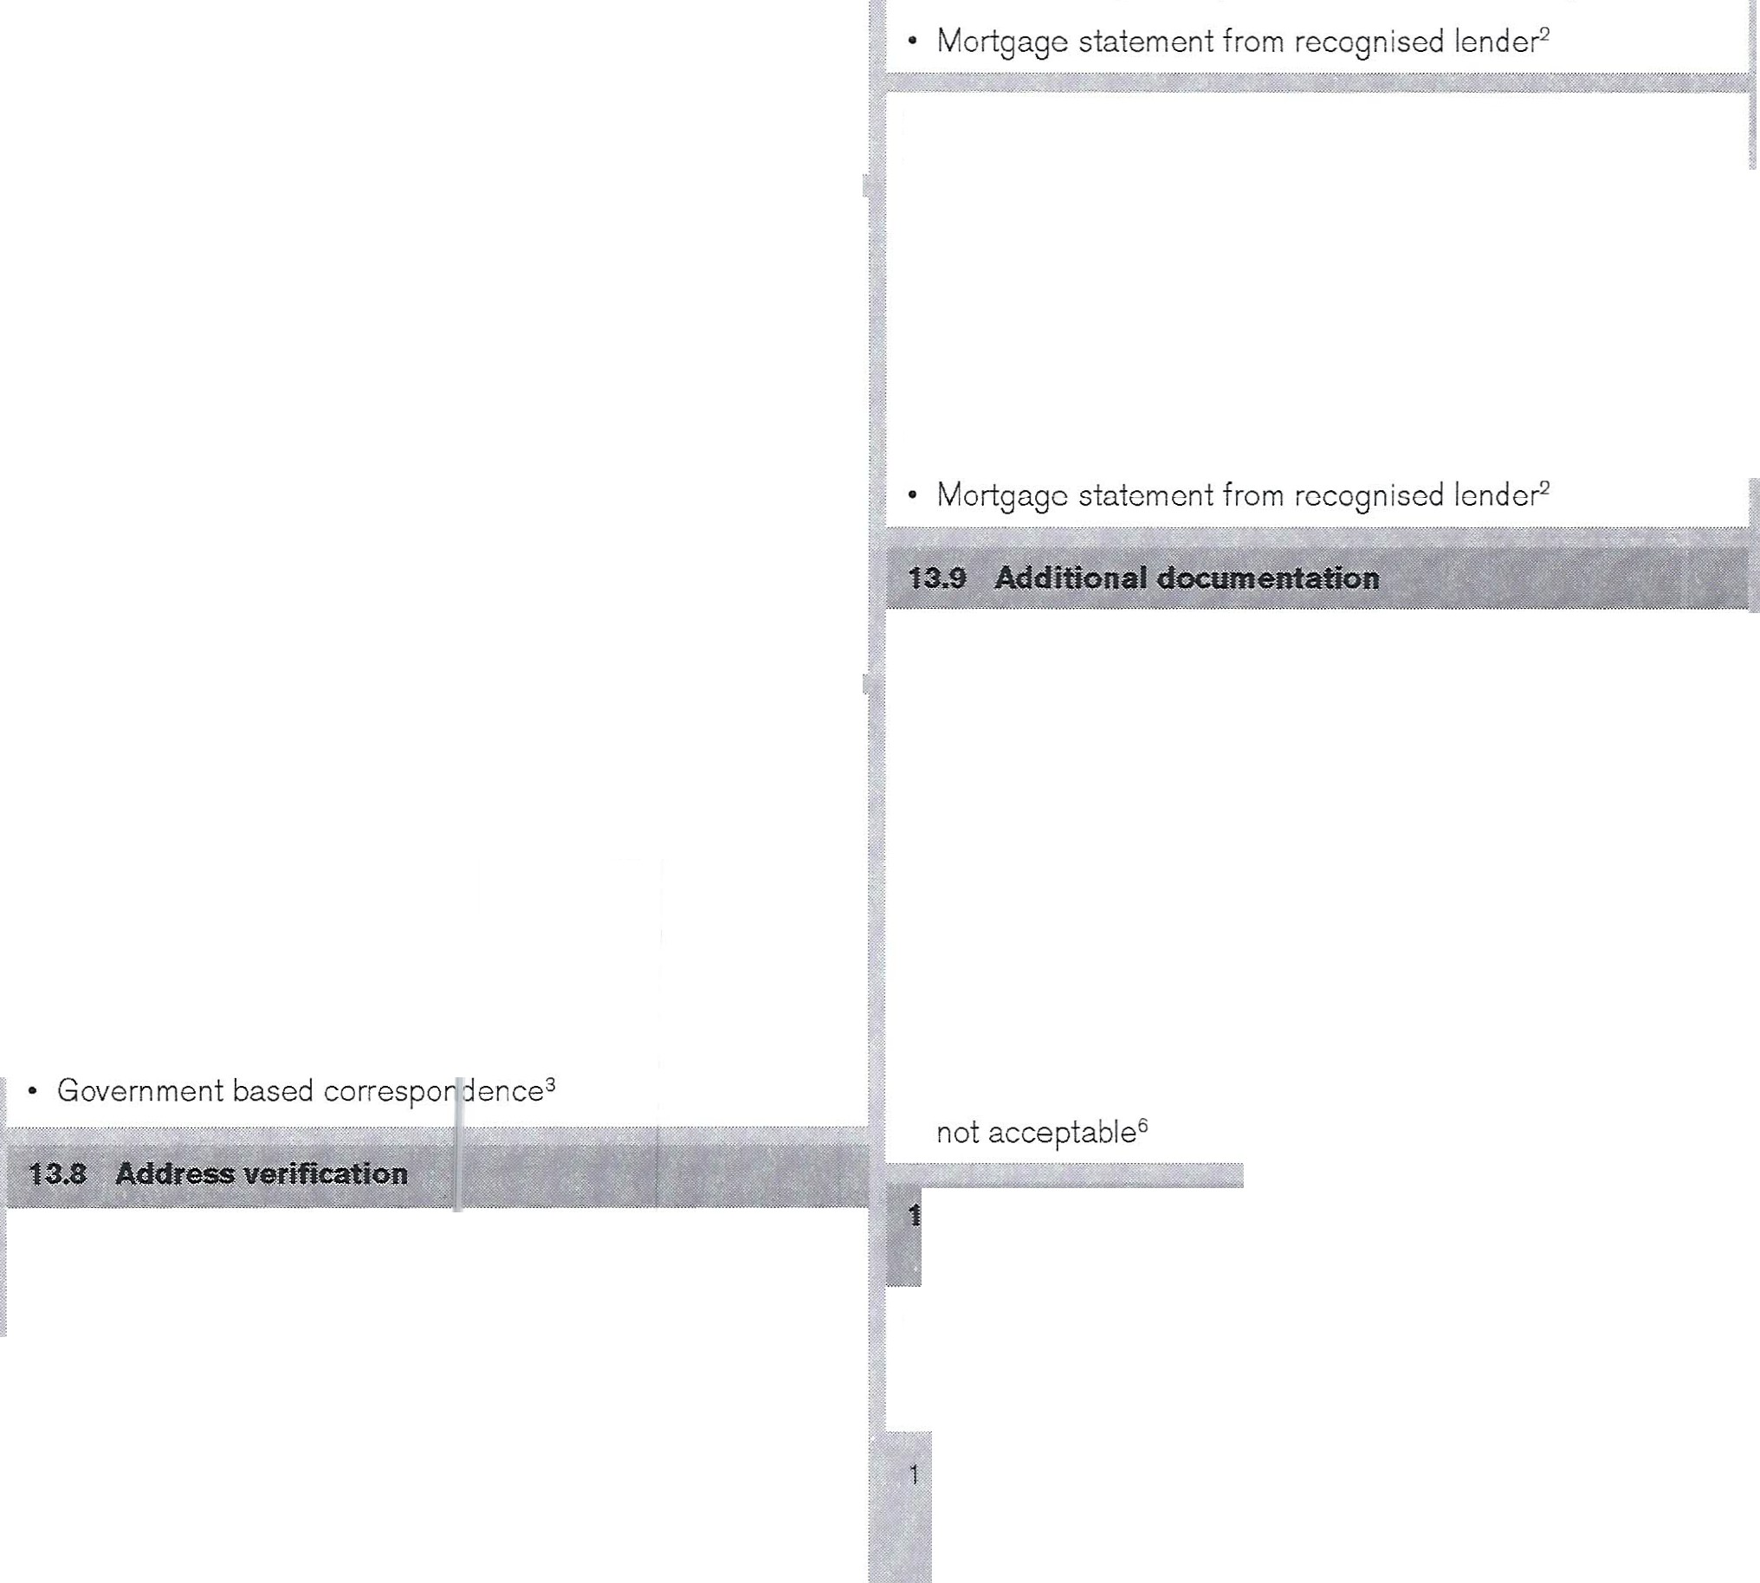



14 D ECLARAT .ONS AN D SIG NATURE(S )

We have received the documents making up the Rathbone Investment Managemeli Limited Agre ment
and Contractual Packs as de$Crlb€ d on Page 3 of this document and confirm we have ag ·eed to Rathbmne Investment Management Limited r' 1anaging and/or advising on the Investments and maintairiin 3 as Sanker,Capital, deposit and Income Accounts on 1ur behalf. subject to the Terms of Business and otnef doc 'Tlents as referred to in
m(;l Tent\s of BwsiMS$ Which mak lup our Agreement.

We confirm we a:re aware of the G ancellation or withdt.i?.Wal rights referred to in the Terms of i 3usiness (in Section 1 "* Our Agreement and our setvlces, under the subheadin9s,
Cancellation rights and Withdrawid r1ghts) under which our Funds e.re to be managed by Rat' 1bone Investment

Management Limited.
We accept that the infonnat on s 1pplied ln this form is only to enable Rathbt;ine lnvestm nt Management Limited
io manage or advise on our inve l:men1 Portfolh!i in accordance with its terms of Bw iness.
We acknowledge that Rathbone nvestment Mana9ement

If there is anything you do not understand, please contact your Investment Manager before you sign and return this Agreement and associated forms.
-
Please note that a minimum of two trustees/directors
or other authorised officers as listed in Section 4 and who have had their identity verified as per Section 13 must sign this document.

-

Date

Signed

Limited is not our general financ al adviser or pensions adviser, and any tax information )tovided is in the context
f\-lp µ\l
d_ ' IJ (G---

of the investment advice and se vices offered. Rathbone Investment Management Llm itei , is the principal trading company and a Subsidiary or R thbone Brothers Pie, and is a bank.
We have read ell of this Client t greement and Profile and we confirm thal: we have pr vided fµll and ac-0urate informal:ion on our persoMl ant financial circumstances

in order that you may manage c r advise on our investments
accordingly. We understand th!$; service that is being provided and that Rathbone Im estment Management LJmited may dlillcltne to act on < ur behalf in the event that the information provided i1 incomplete.
We -0onsent to Rathbone lnves ,ment Management Limited's deallng and best exe ution arrangements and
Name U
\r \;p µ lt.HH.J µ(. er

Date

acknowledge that on some oa :asions when Rathb.one

Investment Management Umii 1>d passes $J1 order to anoiher party for execution, th oo.unterparty'may execute the trade outside a regulated c arket or excllange.
We consent to the vse of our ;>ersonal Data by Rathbone lnv:eJ»fment Man&gement L.imi ed and its group companies (including but not limited to R •thbone Brothers FPlo,

Rathbone Unit rust Manager 1en Rathbone Trust Company,and Rathbone Pen ion and Advisory Services), in accordance with the Terms o1 Business, and the Data Protection Act 1ggg,
We confirm that we have tu11 authority to sign on behalf of the company/trust and if all t irectors/trustees' do not sign,
a resolution 1;1uthorising us w ! oo provided.

Date

Or other auih<:rrl'$ed officeF as described in Sectioo 4 '*" Authorised officer information.

If there are additional signatories and signatures, please enter these in the Client notes Section on Page 24.

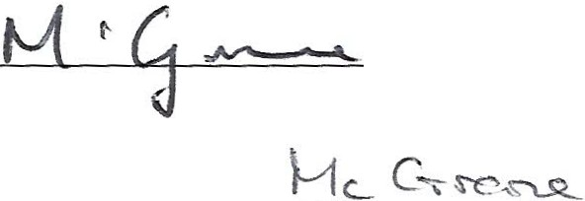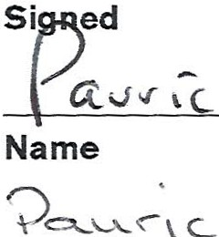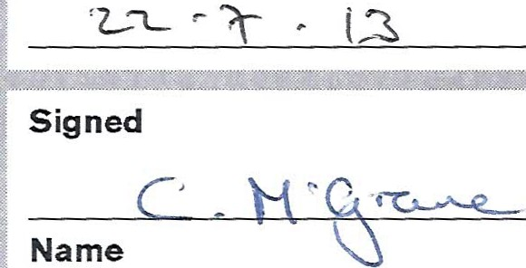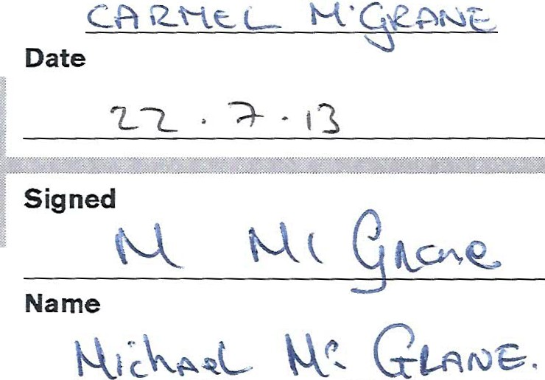



I NVESTME NT MANAG E R NOTES

·.- -., .•. - -,,
Investment Manager

...,._""""'-- """"--·-"'--....... .- -
 | - | - | - | -- |  | - -,--.... -""""'-"""'...,.... """"'""'"""""....."""'
ii ·

"'l



I
Extension
Time
Date
Notes

I NVESTME NT MANAG ER NOTES

'-"'·-''''"">Af- i;;.;="'''''""'
Investment Manager
Extension

Time
Date

Notes

-!-
-

_ _ _ ,)_ _

D





I NVESTME NT tlANAG E R NOTES



Investment Manager

Extension

Time

Date

Notes



30

I NVESTME NT MANAG E R NOTES
-

Investment Manager

Extension

Time

Date

Notes

R<l'llibi:mo!nvestmcm Mii!nlilgcm<mt WmitGd ·.is WJtheri$¢ d tf10 Prodcn'!ial Rcgvl<ltiM i\uthctlfy and rc:golated by lh<> Fin 1m;ial Ccn<!uct Author ity and lite Pn;denlialR\\lgvlntion Authority.
Livcrp¢¢l Suilclirt@, Ik:r H¢llt:f, Llverf1k3 1NW
oor:Oi <1A81J19 1
V Regislratl<>1inumher;G8 241 6883 40
Copyright @ :;?Oi 3.Ratnb"1)e lllrolhcrs Pie A rights rcsctvoo.
RATHBONES
Established ;;,.i.2

