# 

# 

# 

# **2016 Annual Report**

to the Trustees of

**McGrane Haulage Ltd UK**

**Occupational Pension**

**Scheme 2**

Prepared by



# **Index**

**1.** Introduction

**2.** Pension scheme return

**3.** Inflation report

**4.** Economic and markets report

**5.** New pension rules

**6.** The beneficiaries of your pension

**7.** New services

**8.** Changes

**1. Introduction**

We are pleased to enclose our annual report to the Trustees following completion of your tax return.

This report provides a copy of our tax submissions to HM Revenue & Customs on your behalf, together with our comments where relevant. Please take the time to review this and advise us of anything that you are not in agreement with.

In addition to this, we have also prepared the following for you:

• Inflation report and outlook for 2016/17. The purpose of the inflation report is to help your investment decisions, having regard to the likely direction of inflation over the next 12 months.

• Economic and markets report. This summarises in what markets returns are being made, and the likely return on certain asset classes, such as property and equities for the next 12 months.

• A recent news update in the pensions industry. There have been a number of changes since April 2015 and now in April 2016 and we have summarised the key issues and how you may be affected including the reduction in the Lifetime Allowance.

• The rules have changed relating to how pensions are distributed on death. We have summarised these changes for you and in particular, highlighted where pension planning is needed.

• We are pleased to announce the introduction of new services to help you and your business with your pension planning requirements; in particular the new legal requirement to provide a pension where you employ others.

Our role is to ensure that the tax privileges for your pension scheme are maintained. In addition, we seek to add value by providing you with information so that in conjunction with your investment advisor you maximise the growth of your pension fund, in a tax efficient way for you and your business.

Finally, thank you for choosing us to act as the Practitioner for your pension scheme.

**2. Pension Scheme Return**

**Details**

|  |  |  |
| --- | --- | --- |
| Pension Scheme Tax Reference |  | 00804700RB |
| Pension Scheme Name |  | McGrane Haulage Limited  UK Occupational Pension Scheme 2 |
| Is the scheme an Occupational scheme? |  | Yes |
| Tax Year ended |  | 05 Apr 2016 |
| Date submitted |  | 16 Dec 2016 |
| Submitted by |  | Pension Practitioner .Com Limited |
| Scheme Administrator |  | McGrane Haulage Limited |

|  |  |  |
| --- | --- | --- |
| Amended Return |  | No |

|  |  |  |
| --- | --- | --- |
| Accounting Period |  | 06 Apr 2015 - 05 Apr 2016 |

|  |  |  |
| --- | --- | --- |
| During this period, was the aggregate of payments to and from the scheme greater than £100,000? |  | No |
| Specify the aggregate of payments to and from the scheme |  | £15738 |

|  |  |  |
| --- | --- | --- |
| At the end of this period, did the scheme have assets with a total value before pension liabilities greater than £400,000? |  | No |
| Total value of assets before pension liabilities at the end of the period |  | £270969 |

**Connected Parties**

|  |  |  |
| --- | --- | --- |
| At any time during the period from 06/04/2015 to 05/04/2016 did the scheme either directly or indirectly own assets that it had acquired from either: a. a sponsoring employer or any person connected with that employer? *or* b. a person who was a director of or a person connected to a director of a close company that was also a sponsoring employer? *or* c. a person who was either a sole owner or partner or a person connected with the sole owner or partner of a business which was a sponsoring employer? *or* d. a member or person connected with a member? |  | Yes |

**Outstanding Loans**

|  |  |  |
| --- | --- | --- |
| Total amount outstanding at the end of the period |  | £127903 |
| Total amount of any loans made |  | £0 |
| Total amount of any loans repaid |  | £7962 |
| Total amount of interest received |  | £2038 |

**Cash and Bank Information**

|  |  |  |
| --- | --- | --- |
| Total amount of all cash and bank balances at the beginning of the period |  | £0 |
| Total amount of all cash and bank balances at the end of the period |  | £10006 |
| Total amount of interest credited to these accounts |  | £0 |

**Arms Length Transactions**

|  |  |  |
| --- | --- | --- |
| Total cost or market value of any assets owned at the end of the period Specify whether this amount is |  | £133060  Market value |

|  |  |  |
| --- | --- | --- |
| Total amount of income from assets received |  | £1236 |

**3. Inflation Report**

The UK economy slowed a little in 2015 but domestic demand growth remains relatively strong, helped by lower oil prices. The global outlook remains mixed with a gradual pick-up in the US and the Eurozone, but a slowdown in China, continued recessions in Russia and Brazil, and increased volatility in emerging economies and financial markets more generally.

In the scenario below we expect UK GDP growth to average around 2.2-2.3% in both 2016 and 2017. Consumer spending and business investment will be the main drivers of UK growth in these years.

Risks to growth are weighted somewhat to the downside in the short term due to international risks, particularly in relation to emerging markets, as well as uncertainties relating to the EU referendum.

But there are also upside possibilities if the global environment improves and productivity growth rates accelerate in the UK.

London continues to lead the recovery with projected growth of around 3% in 2016 but all other UK regions should also register positive real growth of around 1.4-2.3% per annum this year.

Inflation will remain low this year but seems likely to rise back towards its 2% target by the end of 2017, the MPC may start to raise interest rates gradually during the course of 2017 and beyond. But this now seems likely to be a very slow process and rates could still be only around 2% in 2020.

The Budget is likely to confirm plans for further fiscal tightening to eliminate the budget deficit before the end of this decade. This will impose some drag on the UK economy, but the private services sector should be strong enough to offset this in terms of GDP and jobs growth.

Key Projections

|  |  |  |
| --- | --- | --- |
|  | 2016 | 2017 |
| Real GDP growth | 2.2% | 2.3% |
| Consumer spending growth | 3.0% | 2.5% |
| Inflation (CPI) | 0.5% | 1.6% |

Source: PwC main scenario projections

**4. Economic and Markets Report**

This outlook is completely independent in its focus and should not in isolation be the basis in which to make a financial decision. Please refer to your financial advisor for further advice before making any investment decision, as we are not regulated to provide financial advice. If you do not have a financial adviser we can introduce one to you.

## **UK Economic Forecasts 2016-2020 Outlook**

|  |  |  |  |  |  |  |  |
| --- | --- | --- | --- | --- | --- | --- | --- |
|  | Actual | Q1/16 | Q2/16 | Q3/16 | Q4/16 | 2020 | %/£ |
| GDP Growth Rate | 0.60 | 0.5 | 0.6 | 0.5 | 0.4 | 0.5 | % |
| Unemployment Rate | 5.10 | 4.9 | 4.7 | 4.5 | 4.4 | 6.3 | % |
| Inflation Rate | 0.30 | 0.4 | 0.5 | 0.6 | 0.7 | 2.5 | % |
| Interest Rate | 0.50 | 0.5 | 0.5 | 0.5 | 0.75 | 2.5 | % |
| Balance of Trade | -3459 | -3906 | -3841 | -3809 | -3810 | -3811 | Million£ |
| Government Debt to GDP | 88.60 | 87.1 | 85 | 84.5 | 82.9 | 74.6 | % |

The UK economy has continued its pattern of steady services-led growth over the past year, although the pace of expansion has moderated.

We project that London will be the fastest growing region in 2016 with an output increase of around 3%. Most other UK regions are expected to see positive growth of around 1.7-2.3% in 2016, but Northern Ireland will continue to lag behind somewhat with projected growth of 1.4%.

The UK recovery is still exposed to downside global risks related to possible problems in China and some other large emerging economies leading to further volatility and weakness in international financial markets. However, there are also upsides including the continued feed-through to consumers of the benefits of low oil prices and the possibility of further significant jobs growth.

The Bank of England seems likely to keep interest rates at their record low of 0.5% for some time, with very gradual increases now not expected to begin until 2017. This should help to support consumer spending and business investment in the short term, but could add to the risk of asset price bubbles in the longer term.

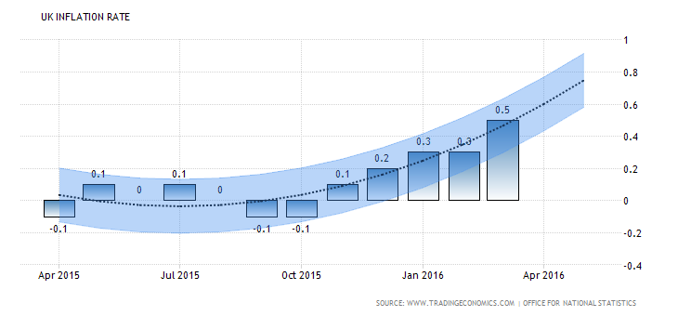

**Stock Markets**

Consumer stocks were the income stars of 2015, with retailers and housebuilders adding to growth, while energy and commodity related companies lagged at the end of the year, as the falling oil price filtered down. Capita warned that as dividend pay-outs lag falling profits, 2016 would be a difficult year for commodity and energy companies. As with market returns, domestically focussed companies in the FTSE 250 outperformed the FTSE 100. Justin Cooper, of Capita Asset Services said investors should prepare for a less successful 2016, predicting a pay-out of £83.8 billion for 2016, and that UK equities will yield 3.9% over the next twelve months, 4% for large cap stocks and 2.9% for mid-caps. “Our forecast for 2016 accounts for £3.4 billion of cuts that have already been announced, but at least an additional £2.1 billion could be at risk. Much speculation surrounds the UK listed oil majors, but they are likely to hold firm for the time being, relying on cost cutting and strong balance sheets to sustain pay-outs.”

# 

# **UK FTSE 100 Stock Market Index Forecast 2016-2020**

## The UK FTSE 100 Stock Market Index is expected to trade at 6000.00 points by the end of this quarter, according to Trading Economics global macro models and analysts expectations. Looking forward, we estimate it to trade at 5510.00 in 12 months time.

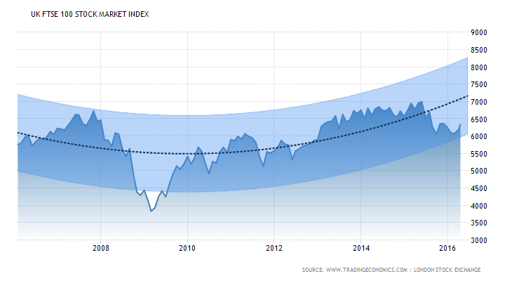

**ETFs - Exchange-Traded Funds**

There are almost 1,200 ETFs listed on the London Stock Exchange and between them they provide exposure to a wide range of different markets. To get the best returns you will need to pick the right indices, but it is a difficult decision when there are so many to choose from.

According to FE Trustnet, there are 48 London-listed ETFs linked to the UK stock market. The top five over the last five years are all benchmarked against the FTSE 250 index with returns of between 101.8% and 102.9%. This is due to the strong outperformance of the mid-cap companies in which they invest.

Two of the five, the HSBC FTSE 250 and DB X-Trackers FTSE 250 UCITS ETF invest in all of the underlying shares, whereas the iShares FTSE 250 UCITS ETF only uses a sample. The others − the Lyxor UCITS ETF FTSE 250 and the Source FTSE 250 − rely on derivatives to synthetically replicate the returns.

Charles Galbraith, managing director of AJ Bell Youinvest, says that after deciding on the asset class and the index, one of the next most important issues is the cost of ownership.

‘Every ETF has an ongoing charges figure, which is an annual cost based on the percentage of the money that you invest. The lower the charge the better it is, in general, but there are also other considerations. For example, if the ETF has a relatively small amount of assets under administration it may be not easy to trade, so the bid/offer spread could be higher.’

The aforementioned five FTSE 250 ETFs all have ongoing charges of between 0.35% and 0.40% per annum. One of the biggest is the iShares vehicle, which has excellent daily trading volumes and a commensurately narrow bid/offer spread of around 0.17%. The DB X-Trackers product also fares well in this respect even though it is considerably smaller.

Picking another benchmark could result in a completely different exposure with better or worse returns, so it pays to think carefully about which index you want to track.

**UK Commercial Property**

The IPD UK Annual Property Index measures ungeared total returns to directly held standing property investments from one open market valuation to the next and for 2015 returned 13.1%.

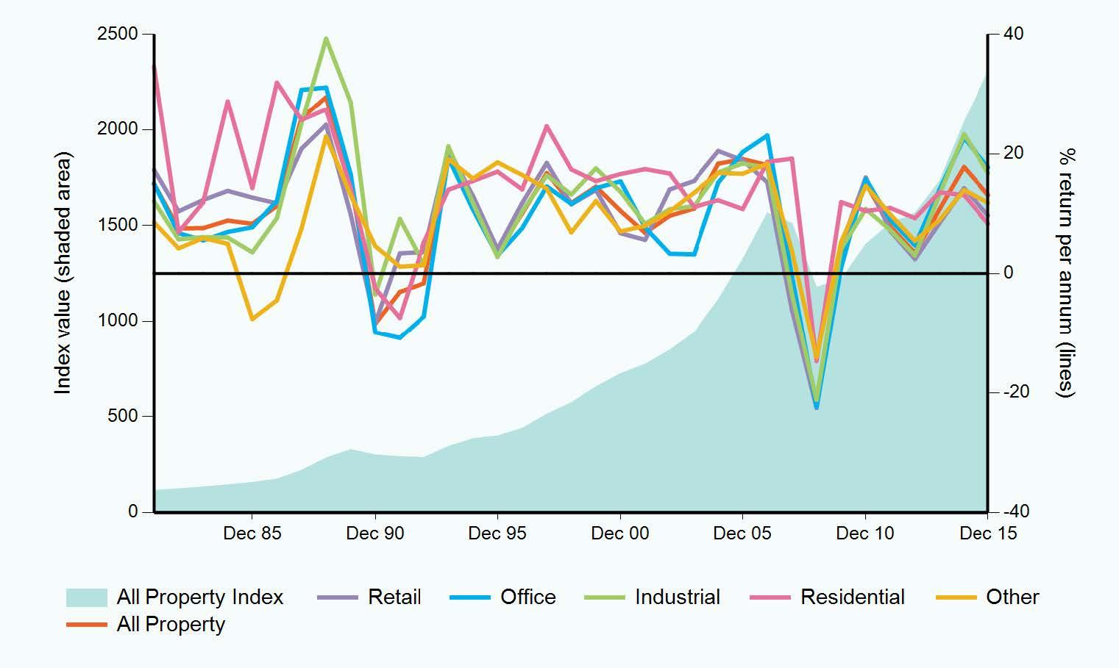

After total returns of 19.3% (IPD 2014) and 13.8% (IPD 2015), the property market has undoubtedly slowed, and we forecast total returns to slow further to c6.5% in 2016, due to Stamp Duty changes (versus our pre Budget forecast of 7%) Returns should stabilise around this level in subsequent years to 2020.

The slowdown in China and other developing economies is reducing world growth. Also, political uncertainty in the Middle East and global debt are adding to volatility, especially in emerging markets. UK GDP growth has slowed since mid-2015, and if the government’s latest, reduced 2% target is not achieved, our rental growth assumptions may be pared back. Outside Central London, rental growth remains patchy.

Also, the looming Brexit Referendum is fuelling uncertainty, and the Chancellor’s reference to "storm clouds" gathering, in addition to Stamp Duty changes in the March Budget, may dampen investor sentiment going forward.

However, in spite of capital growth slowing, commercial property still remains fairly priced. The case for direct property investment remains strong, as long as buyers carry out appropriate due diligence. With 10 year Gilts at c1.5% and an IPD income yield of c4.8%, there remains a healthy positive yield gap of 330bp, in stark contrast to the 2007 market correction. This indicates that property remains fairly priced and a more stable asset when compared to the recent and ongoing volatility in equities and other markets.

Results for the year to 31 December 2015:

|  |  |  |  |  |  |  |
| --- | --- | --- | --- | --- | --- | --- |
| IPD UK Annual Property Index - 1 Year | | | | Annualised total returns | | |
|  | Total return % | Income return % | Capital growth % | 3 YR  % | 5 YR  % | 10 YR  % |
| All Property | 13.1 | 4.8 | 8.0 | 13.8 | 10.5 | 5.7 |
| Retail | 9.7 | 5.0 | 4.5 | 10.8 | 8.3 | 4.2 |
| Office | 17.7 | 4.1 | 13.1 | 18.1 | 13.4 | 7.6 |
| Industrial | 16.8 | 5.4 | 10.9 | 17.7 | 12.5 | 6.4 |
| Residential | 8.3 | 2.8 | 5.3 | 11.6 | 11.0 | 9.6 |
| Other | 11.8 | 5.5 | 6.0 | 11.5 | 10.0 | 7.4 |

|  |  |
| --- | --- |
|  |  |
|  | Offices  With the latest IPD data showing total returns of 17.5% and capital growth of 12.2%, offices were the top performer over the past year according to the IPD Monthly Index. Around half the growth came from yield compression, the rest from income growth and rental values, with the latter being strongest in London. Total returns from City offices (19%) are just ahead of Midtown/West End (18.7%).  Retail  Retail remains the poorest property performer, with all retail delivering 8.7% total returns over the past year, with just 2.6% capital growth and a 5.9% income return. Outside Central London and a few preferred locations, rental growth has been negligible, and rental values have continued to fall in many secondary towns and pitches. |

**5. Latest pension news**

**Changes to Lifetime Allowance scheme that will affect your pension**

**What is it?**

Lifetime Allowance is a limit on the amount of pension benefit that can be drawn from your pension scheme without incurring an extra tax charge. Currently the Lifetime Allowance scheme stands at £1.25m following pension reforms from 2010 onward.

In April 2016 this limit will be reduced to £1m. Any amount over your lifetime allowance that you take as a lump sum is taxed at 55%. Any amount over your lifetime allowance that you take as a regular retirement income – for instance by buying an annuity – attracts a lifetime allowance charge of 25%. This is on top of any tax payable on the income in the usual way.

**How will it affect me?**

If you’re the value pension is approaching or exceeds the lifetime allowance, you must take action or could face unpleasant taxes.

Even if you are not sure that this applies to your situation, it could affect you. Pensions are a long term commitment, and even if your pension fund seems modest now, by the time you come to draw out the benefits it could stand to be a much larger sum, exceeding the lifetime allowance.

**What can I do about it?**

Transitional protections have been introduced, in the form of Fixed Protection 2016 (FP2016) and Individual Protection 2016 (IP2016). We have included the details of these below. HMRC confirmed in Newsletter 73 that you can apply for FP2016 AND IP2016 through an online self-service portal. This will then provide a protection reference number which you can use in order to take benefits using a protected Lifetime Allowance.

**Fixed protection 2016**

FP2016 is available for those that do not already have a previous version of fixed, enhanced or primary protection and do not contribute into or accrue benefits after 5th April 2016. The lifetime allowance will be £1.25 Million.

**Individual protection 2016**

IP2016 is available for those that have pensions valued in excess of £1 Million as at the 5th April 2016. Unlike FP2016, holders of IP2016 will be able to carry on contributing and accruing benefits.

It’s important to be proactive where your pension is concerned, and make prudent decisions with your pension provider’s advice. If you have any questions about the specifics of your pension, please get in touch to find out the best advice for your situation. Contact davidn@pensionpractitioner.com for guidance and reassurance concerning your pension scheme.

**Pension Liberation**

As you may be aware, as part of HMRC’s continuing strategy to combat pension liberation, HMRC made a number of changes to try to strengthen existing processes to deter pension liberation and safeguard pension savings. These changes related to new applications to register pension schemes and for dealing with requests for information about the tax status of a receiving scheme for a proposed transfer.

Pensions liberation fraud is now widespread and as a reputable SSAS provider, it is our duty to protect our clients from fraudulent companies; we always recommend that you obtain professional advice on investments made, in the case of property you should always obtain a valuation from a RICS member and in respect of investments, advice that is protected by the FSCS.

If you have therefore been offered a financial incentive for an investment, we strongly recommend that you notify us in order that we can ensure that the operator is blocked from further business.

**Flexible Retirement options**

A SSAS can take advantage of the recently announced flexible drawdown options to offer control and flexibility in the area of Pension Contributions and Investments. A SSAS is an extremely flexible solution for retirement income drawdown and Business exit options. At the age of 55 you can commence drawdown from your Pension fund. Currently you can draw the first 25% of the fund Tax-free. Because of the recent changes in Pension Legislation, you can take the remainder of the cash as you wish and only pay marginal rate Tax as and when you draw it. Marginal rate means the amount you drawdown will attract PAYE as if it were salary.

For example: If a Members fund holds £200k at age 55, the available Tax free lump sum will be £50k If you choose to take the other £150k at £10k per year, you will pay no Tax on that £10k if you have no other income If you choose to take the entire fund, you will pay a higher rate of Tax under the PAYE scheme at marginal rates. As life changes occur, being in control of your own Scheme allows your choices to change to adapt to your circumstances. If your SSAS owns a Property, you can still receive rent even when you have retired.

**6. The beneficiaries of your pension**

**The distribution of the assets of the pension scheme on death (nominating the beneficiary)**

Pensions are emerging as an important IHT planning tool, thanks to the introduction of new death benefit rules on April 6. These allow the full value of your pension to be passed to a beneficiary tax-free, provided death occurs before the age of 75.

If death occurs after 75, the pension can still be bequeathed tax-free but the beneficiary will pay tax on income taken at their marginal rate. If the whole pension is taken as a lump sum, tax of up to 45pc could be applied. When the beneficiary dies, the money can again be passed on under the same tax treatment.

The debate on which assets to spend in your life has shifted, now it’s perfectly valid to use other assets before your pension because of the abolition of the death tax.

Using a pension to bequeath assets can be a better way to avoid IHT than gifting. The rules covering gifts say that you can give away £3,000 annually, and distribute regular sums of proven “surplus” income. You can also give away other cash or assets but to avoid an IHT charge you must live for at least seven years afterwards. This is known as a “potentially exempt transfer” (PET).

Any lump sum payable from your Pension can be assessed and vulnerable to any of the following if thought is not given to the options available at the time.

Creditors or Bankruptcy If the surviving spouse/partner or a nominated Beneficiary under the new rules is subject to creditor claims.

Bankruptcy or Divorce, the fund is fully at risk where the Beneficiary takes the benefits as a lump sum.

Where a Nominated Beneficiary receives the benefit under the new Flexible Pension Legislation, the fund is also at risk if they Divorce or become Bankrupt.

Remarriage of Surviving Spouse On first death if all the assets become solely owned by or are available to the surviving spouse/partner, what happens if the surviving spouse/partner remarries? All or part of the pension fund could be lost to your children upon the spouse’s/partner’s subsequent Death or Divorce.

Care Costs Following first death, should the surviving spouse/partner need Care, then the whole estate including the family home would be assessed to pay for the cost of that Care. This may include Pension benefits considered ‘available’ to the care user even if they are not taking benefits!

One concern here is that unless specifically Nominated, the Beneficiary cannot gain all the Tax free benefits. Even if that Beneficiary has decided not to take benefits, could their right to take all or any part of the Pension fund be assessed as if their asset or right to income? By not taking these benefits could they be challenged as depriving their estate and Creditors?

The Solution is a family pension death benefit trust where the nominations are contingent on the Trustees accepting or refusing to accept the funds. We would guide you on how to Appoint Trustees to the Family Pension Death Benefits Trust who can then make the decision to accept the pension funds on death or optimise the flexibility and the tax benefits of the new pensions freedom legislation. This may involve keeping it within the pension fund which allows you to hedge your bets. Ultimately it may be difficult to predict the best route to follow as the disposition and character of beneficiaries can change. In such cases, it may be better to "hedge one's bets" by the member establishing the family death benefit trust.

**7. New Services**

**Protection Practitioner**

The changes to pension scheme rules from April 2015 are set to transform pension schemes to operate like bank accounts in retirement; by this we mean you can draw as little or as much as you wish from your SSAS and other private pensions but you will pay income tax on those payments in the UK. Improved rules surrounding death benefits are set to ensure that IHT planning surrounding pensions now plays an important role in overall IHT planning with your business. For example, a trust working in tandem with your pension scheme can ensure succession planning of your personal pension and business assets tax efficiently.

Our launch of the “protection practitioner” service is geared towards delivering trust planning options for you as the member of the SSAS and your business. To contact a consultant, please visit our website: [www.protectionpractitioner.com](http://www.protectionpractitioner.com)

**8. Changes**

**Changes to our Terms of Business**

Pension Practitioner now incorporates a range of other affiliated business partners. Recognising their growth we will be opening an administration office in Gibraltar to also cater for the growing number of clients who have decided to either retire or to relocate some aspects of their business beyond the UK.

You will therefore see some changes to our Terms of Business, specifically to our payments and accountancy functions, which will be managed and administered from Gibraltar.