# Meller SSAS

**Annual Scheme** **Report**



# Index

1. Introduction
2. Fund Composition
3. Scheme Tax Return
4. New Platform
5. Benefits Statements
6. Transactions History
7. **Introduction**

I am pleased to enclose our annual trustee report for your scheme.

We have prepared benefit statement for each of you and can of course tailor this according to your needs and planning requirements.

I also attach with our compliments details of our new platform, which we call Retirement Capital.

Our new online platform is intended to help you get value for money, build retirement capital via Fintech. This is the first of it’s kind for the UK market for SSAS clients and it has taken us a number of years to develop. We hope that this will be of benefit to you. You can of course opt out of this online service, and keep everything as it is. I will contact you separately on this following this report.

I would also like to thank you for choosing us to act as the Practitioner for your pension scheme.

# Fund Composition

The scheme received earnings of £48000, representing before expenses a return on investment of 13% rounded.

# Scheme Tax Return

Below is a copy of our tax report submission for the period ending 5 April 2018 and our supporting comments.

The scheme reporting is one of the most important aspects of scheme management as the data submitted may be reviewed by an Inspector in connection with scheme fund movements. It is particularly important that where transactions are undertaken which may involve the scheme connected to persons or businesses associated with either the scheme members or the employer that we report that information in the correct format.

It is important that clients notify us in advance of any transactions involving either a scheme member, a close connected company or someone connected to a scheme member, such as a relative or business partner.

The following data has been submitted

|  |  |  |
| --- | --- | --- |
| Amended Return |  | No |

|  |  |  |
| --- | --- | --- |
| Accounting Period |  | 06 Apr 2017 - 05 Apr 2018 |

|  |  |  |
| --- | --- | --- |
| During this period, was the aggregate of payments to and from the scheme greater than £100,000? |  | No |
| Specify the aggregate of payments to and from the scheme |  | £0 |

|  |  |  |
| --- | --- | --- |
| At the end of this period, did the scheme have assets with a total value before pension liabilities greater than £400,000? |  | No |
| Total value of assets before pension liabilities at the end of the period |  | £272540 |

**Connected Parties**

|  |  |  |
| --- | --- | --- |
| At any time during the period from 06/04/2017 to 05/04/2018 did the scheme either directly or indirectly own assets that it had acquired from either: a. a sponsoring employer or any person connected with that employer? *or* b. a person who was a director of or a person connected to a director of a close company that was also a sponsoring employer? *or* c. a person who was either a sole owner or partner or a person connected with the sole owner or partner of a business which was a sponsoring employer? *or* d. a member or person connected with a member? |  | Yes |

**Land or Interest in Land**

|  |  |  |
| --- | --- | --- |
| Total cost or market value of any land or interest in land owned by the scheme at the end of the period Specify whether this amount is |  | £176540  Cost |
| Total cost of any land, or interest in land, or premium paid to acquire a leasehold interest in land |  | £0 |
| Total sale proceeds of any land sold, or interest in land sold, or premiums received on disposal of a leasehold interest in land |  | £0 |

|  |  |  |
| --- | --- | --- |
| Were any disposals made to a connected party or connected parties? |  | No |

|  |  |  |
| --- | --- | --- |
| Total amount of income received from land or interest in land |  | £74000 |
| Was any part of the land or interest in land residential property as defined in Schedule 29A of Finance Act 2004? |  | No |

**Cash and Bank Information**

|  |  |  |
| --- | --- | --- |
| Total amount of all cash and bank balances at the beginning of the period |  | £88000 |
| Total amount of all cash and bank balances at the end of the period |  | £96000 |
| Total amount of interest credited to these accounts |  | £0 |

## Connected Party

Connected party covers both the Company sponsoring the scheme and the scheme members. If you are unsure of the connected status of the scheme’s holdings please let us know and we will ensure that you are covered.

The following are connected holdings:

The property at Derby Road was valued in July 2017 and the rental yield estimated must be reflective of the rent chargeable, to ensure that an unauthorised employer payment does not arise. An adjustment has been made in our returns reflecting the late payment of cash credit to the trustees account.

## Arms Length Transactions

Arms length transactions is any person, body or firm that falls outside of the connected part definition given above. It is possible to change from connected party to arms length and vice versa. If you are unsure of the arms length status of the scheme’s holdings please let us know.

There were no arms length investments, save for cash at bank.

# Online Platform

# We have developed a new online platform for you. This will allow you to manage your SSAS and help you build your retirement capital. We have called this platform, Retirement Capital. You will be able to access your account via our new platform aptly named: retirement.capital. Each scheme member will have their own login.

# We are launching the platform in two phases.

# Phase 1 is available now and it will provide you with helpful information including:

# Contribute (your available annual allowance will automatically be updated)

# Take pension benefits – you can set up pension and lump sum instructions via your dashboard.

# Invest into your business – this can be set up as a pension scheme loan.

# Secure the best deposit rates for your SSAS – the latest rates of deposit accounts are available.

# View and change your beneficiaries

# See an immediate forecast of your benefits, with lump sum and pension income.

# A nice pie chart of your holdings

# Immediate cash value of your pension account (for AIB accounts)

# Valuation of other assets

# Online support and live chat

# Tax reporting and scheme management

# Phase 2 will build on these key functionalities and will include online bank instructions to us, property management functionality, online document and statement storage, investment management development through a single dashboard. We will also build on a retirement an phased income calculation tools to help people budget their money in retirement. Phase 2 will be ready in the first quarter of next year. Integrated share trading and dealing will be delivered in the third and final phase.

# Certain investments can be integrated onto your dashboard, this includes funds managed by your financial advisor which offer an API feed, or in the case of a borrowing, your mortgage account. Below is a snap shot of how your account could look:

# 

Your investments are broken down with online functionality that will appear like this. The tabs allow you to undertake certain instructions.

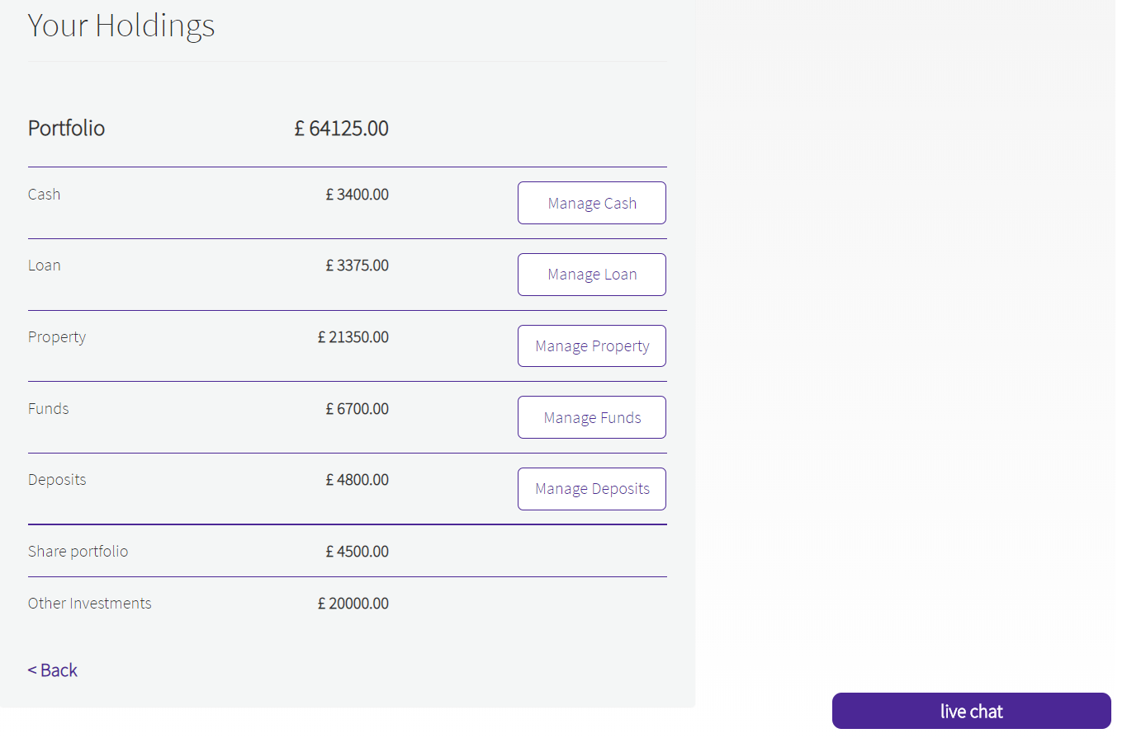

# Benefit Statements

**Benefit Statement for Colin**

Estimated Retirement Fund at age 70: £407,000 Tax Free Cash Sum: £102,000

Pension Income: £20,600 Estimated Retirement Date: 70

We have made the following assumptions:

1. Investment growth is a net rate of 8%
2. Inflation is 2.5% p.a.
3. Pension will not increase in retirement.
4. All figures take account of inflation at an assumed rate of 2.5% p.a.
5. The estimated annual retirement income is based on current annuity rates.
6. No provision has been made for additional contributions.

The figures are a guide and not guaranteed. Your final pension fund and the income available will depend on factors including the growth your fund achieves, contributions you make in future, charges, inflation, your retirement age, annuity rates at the time and the annuity or drawdown options you choose.

**Benefit Statement for Graham**

Estimated Retirement Fund at age 70: £248,100 Tax Free Cash Sum: £61,900

Pension Income: £12,900  
Estimated Retirement Date: 70

We have made the following assumptions:

1. Investment growth is a net rate of 8%
2. Inflation is 2.5% p.a.
3. Pension will not increase in retirement.
4. All figures take account of inflation at an assumed rate of 2.5% p.a.
5. The estimated annual retirement income is based on current annuity rates.
6. No provision has been made for additional contributions.

The figures are a guide and not guaranteed. Your final pension fund and the income available will depend on factors including the growth your fund achieves, contributions you make in future, charges, inflation, your retirement age, annuity rates at the time and the annuity or drawdown options you choose.

# Transactional History

Transactional History for the period to 5 April 2018

|  |  |  |  |  |  |  |
| --- | --- | --- | --- | --- | --- | --- |
| Date | TransactionNarrative | TransactionReference | TransactionType | Debit | Credit | AccountBalance |
| 01/02/2018 | Rental Income | 000220989A | DPG |  | 88,000.00 | 88,000.00 |
| 02/03/2018 | Rental Income - Meller Ltd | 000224673A | DPG |  | 4,000.00 | 92,000.00 |
| 04/04/2018 | Rental Income | 000227916A | DPG |  | 4,000.00 | 96,000.00 |

Transactional History supplementary to October 2018

|  |  |  |  |  |  |  |
| --- | --- | --- | --- | --- | --- | --- |
| 01/05/2018 | MELLER LTD RENT | 000231079A | DPG |  | 4,000.00 | 100,000.00 |
| 08/05/2018 | Property Lease 2018 | 000231607A | WDG | -325 |  | 99,675.00 |
| 24/05/2018 | GDPR Levy | 000233979A | WDG | -195 |  | 99,480.00 |
| 29/05/2018 | MELLER LTD RENT Meller Ltd Rental Income | 530180238 | DPG |  | 4,000.00 | 103,480.00 |
| 28/06/2018 | MELLER LTD RENT Meller Ltd Rental Income | 629225359 | DPG |  | 4,000.00 | 107,480.00 |
| 30/07/2018 | MELLER LTD RENT Meller Ltd Rental Income | 731268681 | DPG |  | 4,000.00 | 111,480.00 |
| 28/08/2018 | MELLER LTD RENT Meller Ltd Rental Income | 829313257 | DPG |  | 4,000.00 | 115,480.00 |
| 06/09/2018 | ICO Renewal ZA138904 | 000246910A | WDG | -35 |  | 115,445.00 |
| 28/09/2018 | MELLER LTD RENT Meller Ltd Rental Income | 1001358710 | DPG |  | 4,000.00 | 119,445.00 |