REPORT & VALUATION

ON

62 HIGH STREET
RYDE
ISLE OF WIGHT
PO33 2RJ

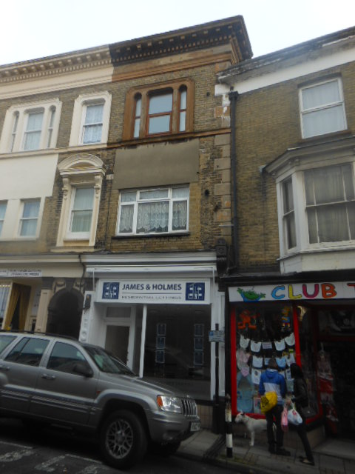

Dated 29th November 2012

1. INSTRUCTIONS

  - Instructions were received from Michael and Janet Holmes Pension Scheme, Pension Practitioner.com of “Daws House”, 33-35 Daws Lane, London, NW7 7SD, to inspect and provide the following advice on the property known as 62 High Street, Ryde, Isle of Wight, PO33 2RJ, strictly in accordance with the RICS Valuation - Professional Standards 2012:-

  - The general condition of the building, identifying any significant defects that will necessitate onerous expenditure in the foreseeable future.

  - The Market Value of the freehold interest as at 22nd February 2012.

  - The Market Value of the freehold interest as at 4th April 2012.

2. INSPECTION

  - T.N.J. Smart FRICS IRRV (Hons) inspected the property on Friday, 23rd November 2012.

  - The Report is founded upon a visual inspection of so much of the exterior and interior of the property as is accessible with safety and without undue difficulty; as can be seen whilst standing at ground level within the boundaries of the site, from the adjacent public highway and also from vantage points within the building.

  - We have not inspected those parts of the property which are covered, unexposed or inaccessible, therefore, we cannot express an opinion about or advise upon the condition of uninspected parts and this Report should not be taken as making any implied representation or statement about such parts.

  - A building survey has not been undertaken, nor have any specific tests been carried out on the services.

  - The weather at the time of the inspection was overcast but dry, there being no climatic restrictions.

  - The shop and premises on the ground floor were vacant, but furnished with floor coverings laid, limiting the scope of the inspection accordingly.

  - The apartments above and behind the shop premises, which are subject to long leasehold interests, were not inspected.

  - The colour photographs shown in the body of this Report were taken at the time of the inspection.

3. SURVEYOR

3.1. The preparation of this Report has been carried out by Tim Smart who is a fellow of the Royal Institution of Chartered Surveyors and a corporate member of the Institute of Revenues, Rating and Valuation.

  - The Surveyor has considerable local knowledge in respect of property matters in the Isle of Wight having undertaken numerous surveys and valuations since qualifying by examination in 1976.

  - The Surveyor has, in respect of the subject property, sufficient current knowledge of the area and the skills and understanding necessary to undertake this valuation competently.

  - The Surveyor is a RICS Registered Valuer.

4. DATES OF VALUATIONS

  - The dates of valuations are 22nd February 2012 and 4th April 2012.

5. PURPOSE OF VALUATIONS

5.1. The valuations have been provided to assist the Client in forward planning.

6. LOCATION

  - The property, the subject of this Report, is situated in a secondary trading area of Ryde convenient to all the local amenities of the town.

  - The area is not in a flood risk zone and to the best of my knowledge has never been affected by flooding.

  - To our knowledge there are no other adverse factors of an environmental nature.

  - We have shown as Appendix A a street plan of Ryde with the approximate position of the property indicated by an arrow.

  - Appendix B shows a copy of the Ordnance Survey extract with the boundaries of the site outlined and edged in red.

7. ORIENTATION

7.1. For the purpose of this Report it is assumed that the front elevation faces west.

8. DESCRIPTION

  - A mid-terraced Victorian property on three floors built in, or around, 1850.

  - Ground Floor

Shop and premises:
Retail Office Area having a frontage of 3.63m widening to 4.20m and a depth of 4.19m giving a total area of some 16.34m² or 170ft².
Kitchen measuring about 1.28m x 3.1m fitted with base and wall units. The working surface incorporates a stainless steel sink unit.
Toilet measuring about 1.27m x 1.18m. Newly installed WC suite and pedestal wash hand basin.

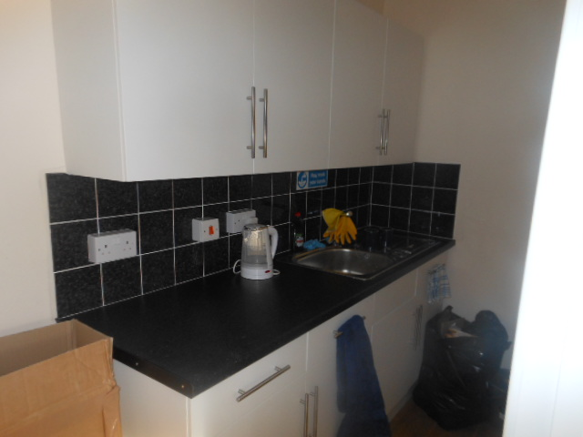 |  | 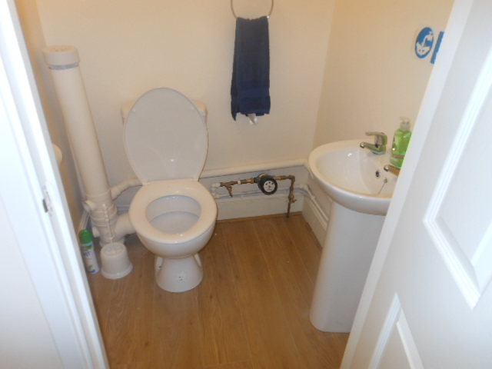

8.3. First Floor
There are three self-contained living units, each subject to long Leases paying a ground rent of £30 (thirty pounds) per annum.

9. CONSTRUCTION

9.1. The property is constructed using traditional materials and techniques. The main walls are a mix of cavity and solid construction with facings of brick, stud and render, all beneath a pitched and slated roof covering. The front elevation finishes in a decorative parapet. The rainwater goods are in PVC pattern. Timber casement windows to the majority of openings. The ground floor is of solid construction with the upper floors suspended.

10. CONDITION OF THE EXTERIOR

10.1. The building is in a satisfactory state of repair for its age and type of construction with no significant defects noted that will have an adverse affect on the market value. As with any property of this age regular maintenance will be required.

11. CONDITION OF THE INTERIOR

  - The shop and premises have recently been refurbished to a good standard of workmanship.

  - The interiors of the three living units have not been inspected, but it is assumed that they have been upgraded and include all of today’s expected amenities.

12. SERVICES

  - We have not tested and cannot comment on whether or not the services comply with the current regulations. The regulations are constantly upgraded and apply retrospectively to previous installations. Fittings that are not new may well, therefore, not comply with the current regulations.

  - Mains electricity, gas, water and drainage are connected to the building.

  - Mains electricity, water and drainage only are connected to the shop and premises.

  - The observed wiring and fittings appear to be of modern style. Hot water is provided by a water heater housed beneath the kitchen sink.

  - Independent electric heaters provide central heating.

  - The property is connected to the public sewer.

13. OUTBUILDINGS

13.1. There are no outbuildings.

14. SURROUNDINGS

14.1. The boundaries of the site are clearly defined. The building occupies it site.

15. TENURE

15.1. The tenure is understood to be freehold subject to three long leasehold interests with each Lessee paying a ground rent of £30 (thirty pounds) per annum.

16. HIGHWAYS

16.1. The property fronts onto Ryde High Street, which is made up and, therefore, adopted by the Local Authority.

17. OUTGOINGS

17.1. It has been assumed in the preparation of this Report that there are none known other than the usual owner/occupier rates and taxes.

18. EASEMENTS

18.1. This Report is based on the assumption that there are no easements, covenants, restrictions or other encumbrances of an onerous nature, which would materially affect the value of the property.

19. PLANNING

19.1. It has been assumed that all buildings have been constructed in accordance with valid Town Planning Consent and Building Regulation Approval and that no conditions have been imposed that might affect the value of the property adversely.

20. BASIS OF VALUATION

  - The basis of valuation used in valuation 1.3. is the Market Value.

  - The definition of Market Value is the estimated amount for which an asset or liability should exchange on the valuation date between a willing buyer and a willing seller in an arm’s length transaction after proper marketing and where the parties had acted knowledgeably, prudently and without compulsion.

21. CONTAMINATION

21.1. Our enquiries have not revealed any contamination affecting the property or neighbouring property, which would affect our valuation. However, should it be established subsequently that contamination exists at the property or on any neighbouring land, or that the premises have been or are being put to any contaminative use this might reduce the values now reported.

22. INDEMNITY INSURANCE

  - It is confirmed that sufficient professional indemnity insurance cover is held in respect of this instruction.

22.2. It is confirmed that the amount of cover currently held is £1,000,000 (one million pounds) for each and every claim.

23. ASSUMPTIONS

  - That good Title can be shown and the property is not subject to any unusual or especially onerous restrictions, encumbrances or outgoings.

  - That the property is freehold.

  - That the property and its value are unaffected by any matters which would be revealed by a local search and replies to the usual enquiries; or by any statutory notice, and that neither the property, nor its condition, or its use, or its intended use, is or will be unlawful.

  - That no deleterious or hazardous materials or techniques were used in the construction of the property or have since been incorporated.

  - That no high alumina cement, concrete or calcium chloride additive or other potentially damaging material was used in the construction of the property or has since been incorporated.

  - That the inspection of those parts that have not been inspected would neither reveal material defects nor cause the Surveyor to alter the valuation materially.

  - That the valuation figure set out in the report assumes a marketing period of six months.

  - That there are no known, likely or potential developments within the locality that would have a material affect on the value of the property.

24. METHODOLOGY AND MARKET CONDITIONS

  - The property has been valued using the comparable method of valuation.

  - The property market remains fairly stable with a number of shops changing hands in the immediate vicinity. There is every expectation that property prices will remain at this level for the foreseeable future.

  - The property is in a satisfactory state of repair with no significant defects noted that will have an adverse affect on the market value.

25. VALUATION

  - The Market Value of the property, the subject of this Report with the benefit of vacant possession of the shop and premises but subject to the three long leasehold interests, as at 22nd February 2012 and 4th April 2012, is considered to be £31,000 (thirty-one thousand pounds).

  - The shop, now refurbished, had a floor area of some 232ft² as at the date of valuation.

  - I have used a Zone A figure of £15 (fifteen pounds) per square foot, which gives a rental value of £3,480 (three thousand five hundred and eighty pounds). I have capitalised the rent using a yield of 11% i.e. YP of 9.09. The total figure equates to £31,633, which I have rounded down to £31,000.

  - The premises required upgrading and if staff were to be employed then the provision of a toilet was essential. I have assumed that the cost of this work to be set off by the value of the ground rents, approximately £2,258.

  - In assessing the value of the ground rents I have used a yield of 4% i.e. YP of 25 giving a total of £2,250.

26. LIABILITY AND PUBLICATION

26.1. The Report is provided for the stated purpose and is for the sole use of Michael and Janet Holmes Pension Scheme and their appointed advisers and the Surveyor accepts no responsibility whatsoever to any other person.

26.2. Neither the whole nor any part of the Report, nor any reference to it, is to be included in any published document, circular or statement, or published in any way, without our written approval of the form and context in which it may appear.

T.N.J. Smart FRICS IRRV (Hons)
Tim Smart Chartered Surveyors

APPENDIX A

A Street Plan of Ryde.

APPENDIX B

An Extract of the Ordnance Survey Sheet.
(Provided under Licence number ES100031707)

