# 2015 Annual Report

to the Trustees of

**Moorfield Garage Ltd SSAS**

Prepared by



# Index

1. Introduction
2. Pension scheme return
3. Inflation report
4. Economic and markets report
5. New pension rules
6. The beneficiaries of your pension
7. New services
8. **Introduction**

We are pleased to enclose our annual report to the Trustees following completion of your tax return.

This report provides a copy of our tax submissions to HM Revenue & Customs on your behalf, together with our comments where relevant. Please take the time to review this and advise us of anything that you are not in agreement with.

In addition to this, we have also prepared the following for you:

* + - Inflation report and outlook for 2015/16. The purpose of the inflation report is to help your investment decisions, having regard to the likely direction of inflation over the next 12 months.
    - Economic and markets report. This summarises in what markets returns are being made, and the likely return on certain asset classes, such as property and equities for the next 12 months.
    - A recent news update in the pensions industry. There have been a number of changes since April 2015 and we have summarised the key issues and how you may be affected.
    - The rules have changed relating to how pensions are distributed on death. We have summarised these changes for you and in particular, highlighted where pension planning is needed.
    - We are pleased to announce the introduction of new services to help you and your business with your pension planning requirements; in particular the new legal requirement to provide a pension where you employ others.

Our role is to ensure that the tax privileges for your pension scheme are maintained. In addition, we seek to add value by providing you with information so that in conjunction with your investment advisor you maximise the growth of your pension fund, in a tax efficient way for you and your business.

Finally, thank you for choosing us to act as the Practitioner for your pension scheme.

1. **Pension Scheme Return**

**Details**

|  |  |  |
| --- | --- | --- |
| Pension Scheme Tax Reference |  | 00818959RP |
| Pension Scheme Name |  | Moorfield Garage Ltd SSAS |
| Is the scheme an Occupational scheme? |  | Yes |
| Tax Year ended |  | 05 Apr 2015 |
| Date submitted |  | 25 May 2015 |
| Submitted by |  | Pension Practitioner.Com Limited |
| Scheme Administrator |  | Pension Practitioner.Com Limited |

|  |  |  |
| --- | --- | --- |
| Amended Return |  | No |

|  |  |  |
| --- | --- | --- |
| Accounting Period |  | 06 Apr 2014 - 05 Apr 2015 |

|  |  |  |
| --- | --- | --- |
| During this period, was the aggregate of payments to and from the scheme greater than £100,000? |  | No |
| Specify the aggregate of payments to and from the scheme |  | £54843 |

|  |  |  |
| --- | --- | --- |
| At the end of this period, did the scheme have assets with a total value before pension liabilities greater than £400,000? |  | No |
| Total value of assets before pension liabilities at the end of the period |  | £53530 |

**Connected Parties**

|  |  |  |
| --- | --- | --- |
| At any time during the period from 06/04/2014 to 05/04/2015 did the scheme either directly or indirectly own assets that it had acquired from either: a. a sponsoring employer or any person connected with that employer? or b. a person who was a director of or a person connected to a director of a close company that was also a sponsoring employer? or c. a person who was either a sole owner or partner or a person connected with the sole owner or partner of a business which was a sponsoring employer? or d. a member or person connected with a member? |  | No |

1. **Inflation Report**

It is important to consider the effects of inflation on pension funds to ascertain any real growth in a pension scheme. Simply put, if your pension fund return over the tax year exceeds that of inflation your fund has grown in real terms and has maintained purchasing power.

CPI and RPI measure change in the prices charged for goods and services bought for consumption in the UK. Prices are recorded monthly for a typical selection of products (referred to as the ‘basket of goods’), using a large sample of shops and other outlets. The CPI target for by the Bank of England’s Monetary Policy Committee (MPC) CPI inflation is 2%.

2014 built on the recovery signs is forecasted to grow above 2.5% annually through to 2017. Growth may still be hampered in the short term due to ongoing Eurozone and international uncertainties, reflected by the slowdown in growth in the fourth quarter of 2014.

The services sector is expected to continue to be the main driver of UK growth for both output and employment, with manufacturing and construction contributing positively to growth into 2015, despite a slowdown towards at the end of last year.

Cheaper fuel, lower energy prices and the ongoing supermarket price ‘war’ all contributed to a sharp decrease in the Consumer Price Inflation indicator which has remained hovering around zero to 1% throughout most of 2015;

This decrease in inflation, combined with a larger than expected increase in wages has meant that there was a positive growth in real earnings, bringing an end to six years of negative real earnings growth. Unemployment levels continued to drop, and have reached their lowest levels since 2008.

It is expected that interest rates will remain at their present low level until 2016, after which they will gradually increase.

## Short and long term forecast

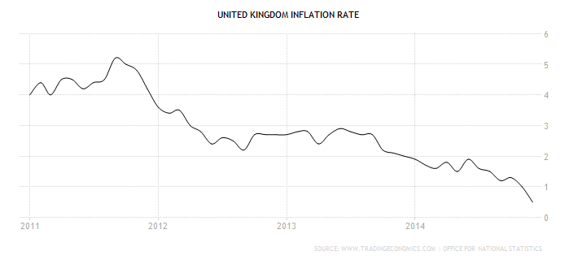

**In summary, inflation will remain at near zero and should increase in 2016 to a target of 2%. Interest rates will remain poor in the immediate future, increasing only gradually from early 2016.**

1. **Economic and Markets Report**

This outlook is completely independent in its focus and should not in isolation be the basis in which to make a financial decision. Please refer to your financial advisor for further advice before making any investment decision, as we are not regulated to provide financial advice. If you do not have a financial adviser we can introduce one to you.

## Stock Market Performance 2014/15

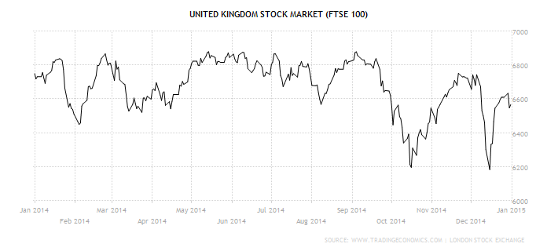

Despite hitting a 14-year high of 6,904.9 in September, the FTSE 100 slumped in the autumn, brought on in no small part by a dramatic fall in commodity and oil prices, along with substantial drops in Sainsbury’s, Morrisons and Tesco. Predictions of a record level by year’s end proved inaccurate, with the FTSE 100 finishing the year 2.7% down, and 2015 predictions are more conservative, with observers warning of large swings throughout the year and the FTSE ending the year marginally down on its starting level at around 6,200.

## Top performers of 2014/15

|  |  |  |
| --- | --- | --- |
| **Company** | **Industry** | **% Gain** |
| **Dixons Carphone PLC** | General Retail | 68.19 |
| **Shire PLC** | Pharmaceuticals | 57.78 |
| [**Ashtead**](http://investing.thisismoney.co.uk/quote/CIR/Circassia-Pharmaceuticals-Ord-008p-share-price) **Group PLC** | Support Services | 52.11 |
| [**London**](http://investing.thisismoney.co.uk/quote/ASTA/Astar-Minerals-Ord-01p-share-price) **Stock Exchange Group PLC** | Financial Services | 38.63  62 |
| **Smith & Nephew PLC** | Health Care | 38.10 |

**If you are seeking income to your scheme through UK equities, the best yielding stocks over the past 12 months in the UK include:** Royal Dutch Shell A (7.53%), HSBC Holdings (6.40%), GlaxoSmithKline (6.20%), Scottish & Southern Energy (6.13%), Vodafone Group (5.14)

Dixon Carphone saw strong interim profits in 2014, aided by TV sales ahead of the World Cup and a busy lead up to Christmas. The share price was further boosted when rival Phones4U collapsed in September. Shire’s share price received a boost from a $1.6 billion breakup fee after the collapse of the merger with US pharmaceutical AbbVie, and further strengthened after sales surpassed expectations.

## If you are seeking to open an online share dealing account, we have negotiated excellent rates for clients – please email us at [info@pensionpractitioner.com](mailto:info@pensionpractitioner.com) with the subject header “trading account” and we will organise this with you or in conjunction with your financial advisor.

**Property**

Continuing the trend over the previous two years, the office sector, especially in Central London, saw strong performance. Sustained economic growth and an increase in business confidence is causing an increase in the number of transactions, despite increasing supply issues in the Capital. Decreasing available space in London is having a knock-on effect as firms look to open up more regional premises. This increase in demand and take up is especially noticeable in Leeds, Reading and Newcastle, which all saw major increases in prime rental growth.

The retail sector continued to struggle outside of Central London. Prime retail rental growth was effectively nil outside Central London, and while an increase in consumer and business confidence may lead to higher demand in these areas, high streets that are already struggling and underperforming may well be passed over in favour of out-of-town developments.

The industrial sector performed well, aided by strong performances by the manufacturing sector, combined with an expansion of the e-commerce sector. Low supply is driving up rents in key locations, and is forcing some occupiers to either compromise on location or having to wait for future developments. The search for availability and investment opportunity will benefit the rest of the UK as occupiers and investors push out further from London and the South East.



1. **Latest pension news**

## Pension liberation

As you may be aware, as part of HMRC’s continuing strategy to combat pension liberation, HMRC made a number of changes to try to strengthen existing processes to deter pension liberation and safeguard pension savings. These changes related to new applications to register pension schemes and for dealing with requests for information about the tax status of a receiving scheme for a proposed transfer.

Pensions liberation fraud is now widespread and as a reputable SSAS provider, it is our duty to protect our clients from fraudulent companies; we always recommend that you obtain professional advice on investments made, in the case of property you should always obtain a valuation from a RICS member and in respect of investments, advice that is protected by the FSCS.

If you have therefore been offered a financial incentive for an investment, we strongly recommend that you notify us in order that we can ensure that the operator is blocked from further business.

## Pension Flexibility 2015

As from April 2015, the long-awaited pension freedoms came into effect, which included the following measures to increase flexibility in relation to pension savings:

* + - Allow you to take the whole of your pension in a SSAS to be taken as a taxed lump sum
    - Increased the flexibility of the income drawdown rules by removing the maximum ‘cap’ on withdrawals and minimum income requirements for all new drawdown funds from 6th April 2015
    - Enabled those with ‘capped’ drawdown to convert to a new drawdown fund once arranged with their scheme
    - Enabled pension schemes to make payments directly from pension savings with 25 per cent taken tax-free (instead of taking a tax-free lump sum)

While the new freedoms will be welcomed by most, attention will need to be paid to the tax implications, especially if total income including pension withdrawals moves you up into the higher rate tax band. In addition, the personal allowance and lifetime allowance is again set to change - we will be reviewing your pension scheme and will guide you how you may be affected.

1. **The beneficiaries of your pension**

Pensions are emerging as an important IHT planning tool, thanks to the introduction of new death benefit rules on April 6. These allow the full value of your pension to be passed to a beneficiary tax-free, provided death occurs before the age of 75. If death occurs after 75, the pension can still be bequeathed tax-free but the beneficiary will pay tax on income taken at their marginal rate. If the whole pension is taken as a lump sum, tax of up to 45% could be applied. When the beneficiary dies, the money can again be passed on under the same tax treatment.

The debate on which assets to spend in your life has shifted, now it’s perfectly valid to use other assets before your pension because of the abolition of the death tax on pensions.

Using a pension to bequeath assets can be a better way to avoid IHT than gifting. The rules covering gifts say that you can give away £3,000 annually, and distribute regular sums of proven “surplus” income. You can also give away other cash or assets but to avoid an IHT charge you must live for at least seven years afterwards. This is known as a “potentially exempt transfer” (PET).

Any lump sum payable from your pension can be assessed and vulnerable to any of the following if thought is not given to the options available at the time.

* + - Creditors or bankruptcy. If the surviving spouse/partner or a nominated beneficiary under the new rules is subject to creditor claims.
    - Bankruptcy or divorce -, the fund is fully at risk where the beneficiary takes the benefits as a lump sum.
    - Where a Nominated beneficiary receives the benefit under the new flexible pension legislation, the fund is also at risk if they divorce or become bankrupt.
    - Remarriage of Surviving Spouse. On first death if all the assets become solely owned by or are available to the surviving spouse/partner, what happens if the surviving spouse/partner remarries? All or part of the pension fund could be lost to your children upon the spouse’s/partner’s subsequent Death or Divorce.
    - Care Costs. Following first death, should the surviving spouse/partner need care, then the whole estate including the family home would be assessed to pay for the cost of that care. This may include pension benefits considered ‘available’ to the care user even if they are not taking benefits.

This can be a complicated area, and these points highlight the considerations. A solution which has attracted a lot if interest is a family pension death benefit trust which gives flexibility to how benefits are paid out on death.

To help deliver that solution, we would guide you on how to appoint Trustees to the Family Pension Death Benefits Trust. Those trustees can then make the decision to accept the pension funds on death or optimise the flexibility and tax benefits of the new pensions freedom legislation. We can provide an independent trustee role through our nominated independent trustee company to ensure independence of the beneficial members and that your wishes are fulfilled.

1. **New Services**

The changes to pension scheme rules from April 2015 are set to transform pension schemes to operate like bank accounts in retirement; by this we mean you can draw as little or as much as you wish from your SSAS and other private pensions but you will pay income tax on those payments in the UK. Improved rules surrounding death benefits are set to ensure that IHT planning surrounding pensions plays now plays an important role in overall IHT planning with your business. For example, a trust working in tandem with your pension scheme can ensure succession planning of your personal pension and business assets tax efficiently.

Our launch of the “protection practitioner” service is geared towards delivering trust planning options for you as the member of the SSAS and your business; the details of which will follow.

We are also pleased to announce the launch of My Workplace Pension; which is an auto-enrolment solution for the small business community. Regulations place a legal requirement on ensuring that you provide a pension scheme for your workers. Our qualifying auto-enrolment scheme is a recognised and accredited scheme, backed by professional indemnity, with membership of the National Association of Pension Funds and funds managed by an experienced and proven fund management team. Our pension consultancy team will contact you in connection with this new legal requirement.