Remitter Advice

Please accept this as confirmation that the following payment was made:

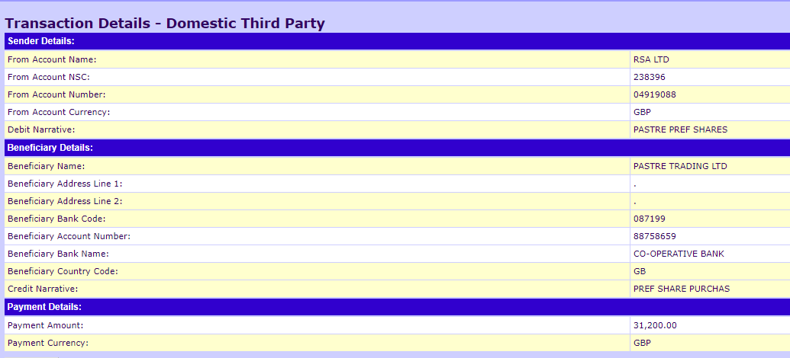

The Payment came from a Pension Scheme Bank account in respect of an investment payment.

Should you require anything further, please don’t hesitate to contact me at emmad@pensionpractitioner.com or by calling 0800 634 4862.

Yours Sincerely

Emma Dane
Senior Pensions Administrator

