

|  |  |  |  |
| --- | --- | --- | --- |
|  | Unity Bay D36 Limited | | |
|  |  |  | 1  0.5 Share |





Rowanmoor Trustees Limited and Susan Savage as

trustees of the SavEnt Limited Executive Pension

Scheme both c/o Rowanmoor House, 46-50 Castle

Street, Salisbury, SP1 3TS, United Kingdom

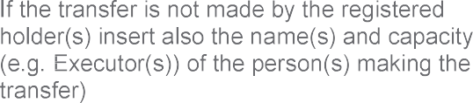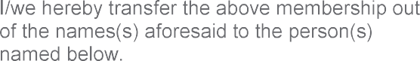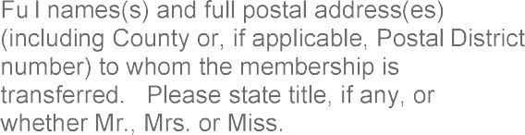

Susan Savage and Oakleaf Trustees Limited

trustees of the SavEnt Limited Executive Pension

Scheme both c/o registered office of Oakleaf

Trustees Limited, 40 Kimbolton Road, Bedford, Bedfordshire, MK40 2NR

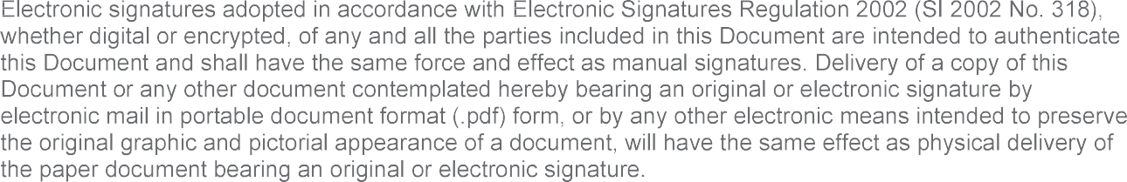

___________ Susan Savage

___________ /Oakleaf Trustees Limited/