# Silvercrest Associates Ltd SSAS

The small self administered pension (SSAS) scheme of Silvercrest Associates Ltd

Pension Practitioner: Pension Practitioner dot com  
Contact: Gavin McCloskey

Trustees: Melvyn Stephen Jones and Ewa Rosciszewska Jones

Beneficiaries: Melvyn Stephen Jones and Ewa Rosciszewska Jones

8 Imperial House, Victory Place, London E14 8BQ

Telephone: 0207 536 0801

# Trustees Report and Accounts 6th April 2012 – 5th April 2013

This report contains historical information about “Silvercrest Associates Ltd SSAS” as well as a report of the year. The profit and loss report and the balance sheet are also included.

Contents

Silvercrest Associates Ltd SSAS 1

Trustees Report and Accounts 6th April 2012 – 5th April 2013 1

Trustees Report including highlights from previous years 3

2011 – 2012 3

2010 – 2011 3

2009 – 2010 3

2008 – 2009 3

Feb 2008 – 2008 3

Information for pension scheme return 4

Value of the fund 4

Assets held 5

Commercial Property 5

Shop: “The Ancient Grudge”, 15 High Street, Tewkesbury 5

Office and shop: 1 Temple Street/ 9 Market Street, Aylesbury 5

Cash 5

Contributions 5

Pension paid out 5

Loan 6

VAT 6

PAYE 6

Tax Return 6

The Pensions Regulator 7

Profit and Loss 8

Balance Sheet 9

# Trustees Report including highlights from previous years

Appointed “The Invisible Book Keeper” to keep the SSAS accounts and transfer them to Sage.

“The Ancient Grudge” shop in Tewkesbury produced a full years rent once again.

Continued with the negotiation to buy “The Boathouse” in Tewkesbury. The intention being to add further parking spaces to it which could be used to provide much needed parking for the shop in “The Ancient Grudge”.

Continued to market the shop and offices in Aylesbury, no tenants were found for either. Investigated further the possibility of letting the offices on short term lets.

Obtained planning permission for restaurant use of the shop in Aylesbury, renovation of the exterior and conversion of the offices to flats.

Ewa Jones transferred her pension from Scottish Widows and Mel Jones his from Standard Life.

## 2011 – 2012

The repaint and repair job on “The Ancient Grudge” Tewkesbury completed in October.

In June the SSAS bought a commercial property in Aylesbury with two floors of offices and a large corner shop with basement. No tenant was found for the offices and the shop tenant went bankrupt. An architect was appointed to look into making the property more attractive for tenants and should no office tenant be found conversion of the offices into flats. Registered for VAT and opted to tax the Aylesbury property. Investigated buying another commercial property in Tewkesbury which could provide parking for “The Ancient Grudge” the property is known as “The Boathouse”.

## 2010 – 2011

A major repaint and repair job was started on “The Ancient Grudge” Tewkesbury. The trustees continued to look for another property to add to the pension scheme. One was viewed in Lymington the other in Aylesbury. A survey and legal advice was taken on the Aylesbury property.

## 2009 – 2010

The SSAS bought a High Street Shop called “The Ancient Grudge” in Tewkesbury.

## 2008 – 2009

The SSAS held cash looking for a commercial property to buy.

## Feb 2008 – 2008

The SSAS was set up in February 2008 by Pension Practitioner dot com. The SSAS held only cash.

# Information for pension scheme return

The pension scheme does not have any interest in tangible moveable property.

The pension scheme does not own any shares in the sponsoring employer.

The pension scheme did not dispose of any shares in the sponsoring company.

The pension scheme does not own or did not acquire any shares in an unquoted company.

The scheme did not acquire any assets directly or indirectly from a connected party.

No member took funds from the scheme other than as pension income.

# Value of the fund

The total value of the fund excluding loans on 31st March 2013 was £688,303.

|  |  |  |  |  |  |  |
| --- | --- | --- | --- | --- | --- | --- |
|  | **2012-13** | **2011-12** | **2010-11** | **2009-10** | **2008-09** | **2007-08** |
| From other pension plans | £69,910 |  |  |  | £91,687 | £82,959 |
| Contributions | £100,000 | £101,572 | £125,950 | £164,178 | £120,000 | £60,000 |
| Total non contribution income | £20,636 | £37,366 | £20,437 | £13,395 | £10,047 | £31 |
| Expenses | £30,719 | £53,763 | £27,930 | £13,172 | £575 |  |
| Pension paid | £24,534 | £24,534 | £24,534 |  |  |  |
| Lump sum made |  |  |  | £131,514 |  |  |
| **Profit and Loss** | **£135,293** |  |  |  |  |  |
| Value of property | £675,000 | £675,000 | £175,000 | £175,000 |  |  |
| Value of cash | £249,193 | £133,007 | £315,899 | £221,976 | £364,150 | £142,990 |
| Loan outstanding | £241,707 | £255,796 |  |  |  |  |
| Creditors | £1,034 |  |  |  |  |  |
| Debtors | £6,851 | £672 |  |  |  |  |
| **Total value of fund** | **£688,303** | £551,540 | £490,899 | £396,976 | £364,150 | £142,990 |

# Assets held

## Commercial Property

### Shop: “The Ancient Grudge”, 15 High Street, Tewkesbury

The SSAS owns the commercial part of 15, High Street, Tewkesbury comprising of a High Street Shop currently let to TAG Estate Agents. The remainder of the property which consists of residential units is owned by the trustees in their own right.

The value of 15 High Street, Tewkesbury, “The Ancient Grudge”, shop part only was given as £175,000 in a valuation undertaken by Downing and Bently in December 2009. The property does not have a VAT option to tax.

### Office and shop: 1 Temple Street/ 9 Market Street, Aylesbury

In June 2011 a commercial property in Aylesbury was bought. The property is on a corner with two addresses, the address of the office is 1 Temple Street and the shop 9 Market Street. The property does have a VAT option to tax. The property was bought for the market price of £500,000.

## Cash

During this period the fund had bank accounts with Halifax Bank of Scotland and Cater Allen.

# Contributions

Contributions made by Silvercrest Associates Ltd into the SSAS and pension transfers.

|  |  |  |  |
| --- | --- | --- | --- |
| Silvercrest Pension Contributions |  | 04/12/2012 | £100,000 |
| Scottish Widows | Ewa | 23/02/2013 | £36,928 |
| Standard Life | Mel | 22/05/2013 | £32,982 |

# Pension paid out

During the year the following pension was paid:-

Melvyn Jones Gross £12,386  
Ewa Jones Gross £12,148

No lump sum was paid out.

# Loan

A loan was taken out to buy 1 Temple Street/9 Market Street, Aylesbury in Junw 2011.

The loan is and was less than 50% of the value of the fund.

The trustees took in their own name a mortgage on their own flat from HSBC of £300,000 at 1.79% above base rate, currently at 0.5%, for 16 years. The interest is therefore 2.29%. The purpose of the loan was partly to loan to the SSAS enough money to purchase the Aylesbury property. The terms of the loan from the trustees to the SSAS are exactly the same as that obtained from HSBC by the trustees.

The SSAS loaned from the trustees £265,000 part of a £300,000 mortgage taken by the trustees on the exact same basis as the trustees obtained from the mortgage provider HSBC.

**The amount outstanding at 31st March 2013 was £241,707**

# VAT

The pension fund was registered for VAT on 31st May 2011 with registration number “111 5752 46”. This was because of the purchase of the property in Aylesbury which was subject to VAT.

An option to tax was taken on 1 Temple Street/9 Market Street Aylesbury during the conveyancing of the property.

The SSAS is in the annual accounting scheme with a VAT return due on 31st March each year.

# PAYE

Paye tax must be paid on the pension paid to the Trustees. Calculation of tax and administration of the SSAS PAYE scheme is done by Pension Practitioner dot com.

PAYE references

Sefot Area, The triad, Stanley Road, Bootle L75 1HT  
PAYE Employer Reference: 083/GA46074  
Account Ref: 083PP00228289

# Tax Return

Pension Scheme Tax Reference 00712161RC registered since 22nd February 2008

A return for the SSAS is required each tax year. Tax returns for 07-08, 08-09 and 09-10 were made by the Trustees. All subsequent returns have been made by Pension Practitioner dot com

# The Pensions Regulator

The SSAS is registered with the pension regulator and is required on an annual basis to fill in a return. This return will be made by Pension Practitioner dot com.

There was a mix up in registering the SSAS with the pension regulator which resulted in two Registration numbers being allocated. This has been resolved with the second registration number 12001911 being removed and the following number retained:

Scheme Key H65RL1ARDQZY Pension Scheme Registration Number: 1027638

# Profit and Loss

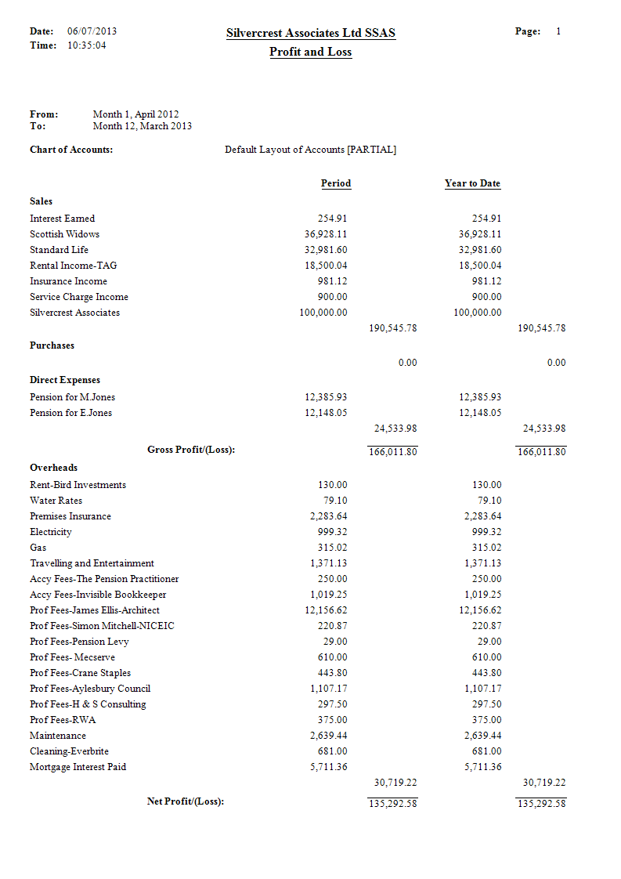

# Balance Sheet

