2009-2010
Annual Report to the Trustees
of
SILVERCREST ASSOCIATES LTD SSAS

Index

Introduction

Tax Return and other disclosures to HMRC & The Regulator
- HMRC and Regulatory Requirements
- Pension Rules Changes in 2011
- Investment and Inflation Yields
- Pension Schemes Online Service
- Retirement Benefits Review

- Introduction
Pension Practitioner .Com provides administration services to the Trustees, and our responsibility is to ensure that the tax exempt privileges of the pension scheme are maintained.
This report has been prepared to provide you with the following information:
- Disclosures to HMRC and the Pensions Regulator
- A review of the scheme rules in light of legislation in 2011
- An assessment of the scheme yield against inflation for the tax period.
- Provision of member benefits statements
- To draw to the attention of the Trustees any specific matters regarding the scheme’s investments and governance.

Tax Return and other disclosures to HMRC & The Regulator
The pension scheme return provided to HMRC must end after 6th April 2009 and before 5th April 2010. The accounts therefore relevant for the period are to the year ending 5th April 2010. The trustees can have the accounts tie in with the tax year should they choose.
The following disclosures have been submitted:
The value of the assets at 5th April 2010 amounted to £396,975, the movement of funds are represented by:
Total pension contributions: £164,177
Total lump sum paid out: £131,513
Rent payments received from TAG: £7,143
Difference between amount paid for the shop and its valuation: £5,000
Bank interest: £1,252
Expenses: £13,172
No enquiries at the date of this report have been raised by HMRC or the Regulator.
There were no reportable event reports at the date of the return to HMRC
There were no reportable events to the Pensions Regulator at the date of the return
We have made no adjustment to the pension returns to HMRC.

- HMRC and Regulatory Requirements

HM Revenue & Customs have responsibility for the administration of pension scheme tax reliefs and payments. The Pensions Regulator is concerned with ensuring that member pension benefits are preserved in accordance with the rules of the scheme and that Trustees undertake good scheme governance.

The pension scheme’s operation is not regulated by the Financial Services Authority. The reason for this is because the trustees hold and invest money for themselves as beneficiaries of the pension scheme. This does not mean that investments made by the trustees are not covered by the Investors Compensation Scheme. Where funds are lodged with a firm that is regulated by the FSA (or via a passport EEA country) any institutional failure that arises will qualify for a claim through the investors compensation scheme.

Our role is to act as agent of the trustees and to ensure that the scheme meets it’s reporting and compliance obligations to the respective regulatory agencies. To ensure that all investments made do not give rise to a tax charge, the trustees must notify us in advance of certain transactions. These can be summarised as:

- Purchase of any unquoted shares
- Property purchase/disposal
- Purchase of goods and materials, such as plant and machinery and other tangibles
- New loans and borrowings, failure to meet current pension loan repayments
- Drawings from the scheme as expenses or otherwise
- Transferring money to other pensions

By giving us advance notice, we will help ensure that taxable transactions are minimised. It should be noted that where the scheme cannot meet a liability for a tax charge, the trustees could be personally liable. Please therefore ensure that we are notified in advance of any activities that fall into the above categories.

- Pension changes in 2011.
In 2010, a number of changes were proposed for pension schemes, which will come into effect in 2011 and 2012. This part of the report looks at those changes and how you might be affected.
Annual Allowance
Each person has an annual allowance which limits the scope of pension contributions that can be made for tax relief deduction. Unlike the previous proposals, you or your business will qualify for tax relief at the marginal rate.

If you do not expect to pay more than £50,000 for 2011/12 onwards, then you will not be affected by the change. If you expect to pay more than this, then you could incur a tax liability on the payment above £50,000.

To ensure that there is not a surge in pension contributions prior to the new contribution limits, anti-forestalling rules have been introduced by HMRC. Not everyone is affected by the anti-forestalling rules and we will take this into consideration in our guidance.

We will give you (or where you have a financial advisor/accountant appointed to the scheme, joint) specialist guidance. Please therefore get in touch with us as soon as possible, if you think you might be affected. The closer it gets to 5th April 2011 the more limited we will be on the assistance we can give you.
Pension Income and Inheritance Tax Changes
In last year’s emergency Budget on 22 June 2010 and published in the Finance Bill 2010, further changes were proposed to the treatment of inheritance tax. It affects any member who reaches the age of 75 on or after 22 June 2010.
It allows those persons who reach 75 to continue drawing their pension as unsecured income from the scheme up to age 77. This normally allows higher levels of income to be paid than would otherwise be the case where a member at 75 was required to adopt other forms of pension income.
If a member of the pension scheme dies after reaching the age of 77 any of the remaining fund not used to pay either pensions to dependants or a charitable donation, is subject to tax charges up to 70 per cent. We can give specific scheme tax guidance in this area if requested.
State Pensions
The method of calculating state pension increase will change. State pension was up-rated by the higher of price inflation or 2.5 per cent. CPI (Consumer Price Index) will be introduced used as a third measure for pension increases from April 2011. The new changes will introduce CPI, and therefore where CPI (it is presently about 3.4%), is greater than earnings or 2.5% the basic state pension will increase by that higher amount. It will not be extended to the earnings related pension/state second pension.

State Pensions
The method of calculating state pension increase will change. State pension was up-rated by the higher of price inflation or 2.5 per cent. CPI (Consumer Price Index) will be introduced used as a third measure for pension increases from April 2011. The new changes will introduce CPI, and therefore where CPI (it is presently about 3.4%), is greater than earnings or 2.5% the basic state pension will increase by that higher amount. It will not be extended to the earnings related pension/state second pension.

- Investment Yield

The objective of the scheme is to exceed inflation and sustain retirement income.
The Consumer Price Index (CPI) is now regarded as the preferred approach to the measurement of inflation, it does this by tracking the changing cost of a fixed basket of goods and services over time. RPI, which is also an inflation measurement index is presently adopted for the cost of indexed linked gilts and other market indices. RPI is therefore more relevant when measuring the cost of pensions in payment and CPI the present and historical measure of inflation.

CPI Inflation for the tax period of 2009/19 was averaged at 3.1%. RPI for the same tax period average at 4.4%.

A graph below illustrates the trend of both CPI and RPI.
Percentage changes

 |  |  |  |  |  |  |  | 6
 |  |  |  |  |  |  |  | 5
 |  |  |  |  |  |  |  | 4
 |  |  | CPI |  |  |  |  | 3
 |  |  | CPI |  |  |  |  | 2
 |  |  |  |  | RPI |  |  | 2
 |  |  |  |  | RPI |  |  | 1
 |  |  |  |  |  |  |  | 0
 |  |  |  |  |  |  |  | -1
 |  |  |  |  |  |  |  | -2
Nov | Feb | May | Aug | Nov | Feb | May | Aug | Nov
2008 |  |  |  | 2009 |  |  |  | 2010
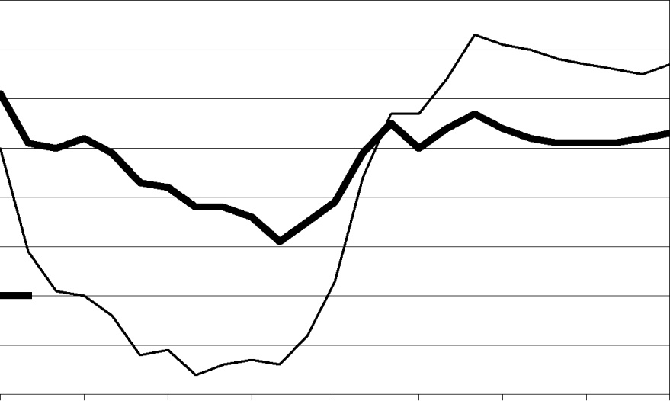

By way of a guide to the industry average, the yield achieved by the average of occupational pension funds for 2009/10 was 13.4% as a bench mark index. This yield is the first positive yield for some time, following a drop of -13.4% in 2008. Next year, we shall be giving a yield comparison against the cumulative average of return of other schemes under our administration.

- Pension Schemes Online
Since 2008, we have been developing a secure online service for clients to help get the best benefit out of their pension scheme.
The secure online gateway will allow you and your professional advisors a number of innovative solutions that are not offered by any other pension administration company.
- We have uprated the pension calculators which were formerly on the Pension Practitioner website to host the most current pension rates in the market and give a greater range of calculation options.
- You can view all of the best pension bank account and building society rates in the UK. You may select the best deals and download the application form direct from the provider. This service is not available through money supermarket or any other pension website.
- View all land and property auctions and download the most current listings
- Join our online directory which will allow you to showcase your services through your business to others firms. This will add internet traffic to your business and help you grow. By way of an example, our key domain words are searched 13.500 every month in the UK.
Please feel free to find out more by visiting http://www.pensionpractitioner.com and watching our short video. We will be in touch with you shortly on registering for this service. This service is covered by your annual administration fee.

- Retirement Benefits Review

With reference to our letter issued to you on 16th June 2010, a crystallised fund of £198,487.95 was available to be used for pension drawdown in respect of each member. On this basis, a maximum gross pension of £12,386 for Mel and £12,148 for Zuzanna p.a. can be drawn from the fund.

Under current legislation, the income that may be taken is subject to limits set by the Government Actuary’s Department (known as the GAD rate). The minimum income is zero, so a member may choose to take no income at all, and the maximum income is 120% of the appropriate GAD rate. Income can be varied between these limits at any time. At present, the maximum income levels are reset every five years. The next review date for your scheme will be October 31st 2014. October 31st 2009 is the date at which the first crystallisation event took place.

New legislation changes to income drawdown will apply from April 2011. All income drawdown investors will see changes in the withdrawal limits as the system is overhauled. The current drawdown method you are using (known as unsecured pension option- UPO) will be replaced with ‘Capped drawdown’. From April, the most any new scheme entering drawdown will be able to draw as a pension will be 100% of GAD rates, but this will only apply to your scheme as of the next review date. It is also worth noting that under current drawdown rules the drawdown limit is reviewed every five years, this will change to every three years upon change to capped drawdown until age 75, and then annually.

We are currently in the process of putting together an offshore pension facility, which features preferential treatment compared with UK registered pension schemes, particularly with regard to a reduced tax rate on lump sum death benefits, more flexible income drawdown rules as s favourable pension laws in the jurisdiction (Isle of Man) in which the offshore product will be provided. We will let you know about this in due course once the arrangement has been finalised with HMRC and the Regulator. The assets would remain here in the UK but the reporting would be undertaken through Isle of Man.

