# SILVERCREST ASSOCIATES

# LIMITED SSAS

**Trustee Report 2018**



**Index**

1. Introduction
2. Fund Composition
3. Scheme Tax Return
4. New Platform
5. Benefit Statement
6. **Introduction**

I am pleased to enclose our annual trustee report for your scheme.

Your benefits statements will be accessed through the platform account. We launched recently a new platform for you to help you get get value for money, and build retirement capital via Fintech. This is the first of it’s kind for the UK market for SSAS clients and it has taken us a number of years to develop. We hope that this will be of benefit to you. You can of course opt out of this online service, and keep everything as it is. I will contact you separately on this following this report.

I would also like to thank you for choosing us to act as the Practitioner for your pension scheme.

# Fund Composition

There have been no investment changes with the Scheme.

# Scheme Tax Return and Reporting

Below is a copy of our tax report submission for the period ending 5 April 2018 and our supporting comments.

The scheme reporting is one of the most important aspects of scheme management as the data submitted may be reviewed by an Inspector in connection with scheme fund movements. It is particularly important that where transactions are undertaken which may involve the scheme connected to persons or businesses associated with either the scheme member or the employer that we report that information in the correct format.

It is important that clients notify us in advance of any transactions involving either a scheme member, a close connected company or someone connected to a scheme member, such as a relative or business partner.

|  |  |  |
| --- | --- | --- |
| Pension Scheme Tax Reference |  | 00712161RC |
| Pension Scheme Name |  | Silvercrest Associates Ltd SSAS |
| Is the scheme an Occupational scheme? |  | Yes |
| Tax Year ended |  | 05 Apr 2018 |
| Date submitted |  | 15 Jan 2019 |
| Submitted by |  | The Practitioners Partnership LP |
| Scheme Administrator |  | SILVERCREST ASSOCIATES LIMITED |

|  |  |  |
| --- | --- | --- |
| Amended Return |  | No |

|  |  |  |
| --- | --- | --- |
| Accounting Period |  | 06 Apr 2017 - 05 Apr 2018 |

|  |  |  |
| --- | --- | --- |
| During this period, was the aggregate of payments to and from the scheme greater than £100,000? |  | No |
| Specify the aggregate of payments to and from the scheme |  | £64701 |

|  |  |  |
| --- | --- | --- |
| At the end of this period, did the scheme have assets with a total value before pension liabilities greater than £400,000? |  | Yes |

**Connected Parties**

|  |  |  |
| --- | --- | --- |
| At any time during the period from 06/04/2017 to 05/04/2018 did the scheme either directly or indirectly own assets that it had acquired from either: a. a sponsoring employer or any person connected with that employer? *or* b. a person who was a director of or a person connected to a director of a close company that was also a sponsoring employer? *or* c. a person who was either a sole owner or partner or a person connected with the sole owner or partner of a business which was a sponsoring employer? *or* d. a member or person connected with a member? |  | No |

**Cash and Bank Information**

|  |  |  |
| --- | --- | --- |
| Total amount of all cash and bank balances at the beginning of the period |  | £135938 |
| Total amount of all cash and bank balances at the end of the period |  | £159779 |
| Total amount of interest credited to these accounts |  | £222 |

**Arms Length Transactions**

|  |  |  |
| --- | --- | --- |
| Total cost or market value of any assets owned at the end of the period Specify whether this amount is |  | £675000  Market value |

|  |  |  |
| --- | --- | --- |
| Total amount of income from assets received |  | £41918 |

There were no activities to report which fell under AFT reporting HMRC.

The following activity references apply to this scheme:

|  |  |
| --- | --- |
| **Payment** | **When the charge applies** |
| Short service refund lump sum charge | Payable when the scheme refunds contributions to a member who was a member for less than 2 years. |
| Lifetime allowance charge | This tax is due when the scheme pays a pension to a member and they’ve used up their lifetime allowance. |
| Special lump sum death benefit charge | A 45% tax due if the scheme pays certain sums |
| Serious ill-health lump sum charge | From 16 September 2016 the serious ill-health lump sum payment is treated as taxable income and will form part of the Real Time Information (RTI) reporting that pension scheme administrators have to do. |
| Authorised surplus payments charge | A 35% tax that is due if the scheme pays surplus scheme funds to an employer. |
| De-registration charge | A tax charge of 40% of the pension scheme value if HMRC removes the tax registration of the pension scheme. |
| Annual allowance charge | Where the member has given the scheme administrator a notice requiring them to pay the tax for the member. |
| Overseas transfer charge | A tax charge of 25% on taxable overseas transfers made from 9 March 2017. |

**Arms Length Transactions**

Arms length transactions is any person, body or firm that falls outside of the connected part definition given above. It is possible to change from connected party to arms length and vice versa. If you are unsure of the arms length status of the scheme’s holdings please let us know.

The arms length holdings were submitted as cash at bank, plus property. There were no event reports arising in the scheme year which are updated as:

|  |  |
| --- | --- |
| **Event report number** | **Details of events to be reported** |
| 1 | The scheme made or is treated as having made an unauthorised payment. |
| 2 | Payments of lump sum death benefit(s) of more than 50% of the lifetime allowance. |
| 3 | Payment of benefits to a member under age 55 who is a scheme employer, director of a scheme employer (or associated company) or connected to such a person. |
| 4 | Payment of a serious ill-health lump sum to a member who is a scheme employer, director of a scheme employer (or associated company) or connected to such a person. |
| 5 | The scheme stops paying out an ill-health pension. |
| 6 | A member’s benefits are tested against the lifetime allowance (a benefit crystallisation event) and:   * they have an enhanced lifetime allowance, enhanced protection, fixed protection, fixed protection 2014 or individual protection 2014 * their total benefits are more than the lifetime allowance   The Event Report does not currently include fixed protection 2016 (FP2016) and individual protection 2016 (IP2016), so you will not be able to use the 2016 to 2017 or 2017 to 2018 Event Reports to report reference numbers of your members relying on FP2016 or IP2016 from 6 April 2016.  If your members have relied on fixed protection 2016 or individual protection 2016. |
| 7-8A | Payment of a stand-alone lump sum (100% lump sum) and the member had either:   * protected lump sum rights of more than £375,000 with either primary protection or enhanced protection * scheme specific lump sum protection and the lump sum is more than 7.5% of the lifetime allowance |
| 9 | A transfer to a qualifying recognised overseas pension scheme (QROPS) where the transfer was requested before 6 April 2012. |
| 10 | The scheme becomes or stops being an investment regulated pension scheme. |
| 11 | The scheme changes its rules to either:   * require the scheme to make an unauthorised payment * allow the scheme to have investments other than insurance policies |
| 12 | A scheme treated as 2 schemes by HMRC before 6 April 2006 changes any of its rules. |
| 13 | The scheme’s structure changes. |
| 14 | The number of members at the end of the tax year has changed band compared to the band at the end of the previous tax year. The bands are:   * 1 member * 2 to 11 members * 12 to 50 members * 51 to 10,000 members * more than 10,000 members |
| 18 | The scheme administrator is subject to a scheme sanction charge because of investment in taxable property. |
| 19 | The scheme changes its country of establishment. |
| 20 | The scheme becomes or stops being an occupational pension scheme. |
| 20A | The scheme becomes or stops being a Master Trust scheme. This must be reported within 30 days of this event. |
| 21 | The scheme administrator has automatically issued a ‘standard’ pension savings statement |  |
| 22 | The scheme administrator has automatically issued a ‘money purchase’ pension savings statement |  |

# Online Platform

We have developed a new online platform for you. This will allow you to manage your SSAS. You will be able to login and access your account and investments, we have called this platform: retirement capital.

We are launching the platform in 3 phases.

Phase 1 is available in now and it will provide you with helpful information including:

1. Contribute (your available annual allowance will automatically be updated)
2. Take pension benefits – you can set up pension and lump sum instructions via your dashboard.
3. Invest into your business – this can be set up as a pension scheme loan.
4. Secure the best deposit rates for your SSAS – the latest rates of deposit accounts are available depending on your chosen investment and term.
5. View and change your beneficiaries
6. See an immediate forecast of your benefits, with lump sum and pension income.
7. A nice pie chart of your holdings
8. Immediate cash value of your pension account (for AIB accounts)
9. Valuation of other assets
10. Online support and live chat
11. Tax reporting and scheme management

Phase 2 will build on these key functionalities and will include online bank instruction, document storage, stocks and share trading. We will also build on retirement and phased income calculation tools in phase 3.   
  
Integrated share trading and dealing will be delivered by the spring of 2019, and we are working with our development team on share dealing integration at this time.

The key feature of this platform is that it brings together all the features of your SSAS under one roof, securely and in a user friendly way so you have a holistic picture of your S. This platform will allow you to access and manage your pension fund in a way which suits you, with access to a range of options which are unique to your small self administered scheme.

Certain investments can be integrated onto your dashboard, this includes funds which offer an API feed. Below is a snap shot of how your account could look

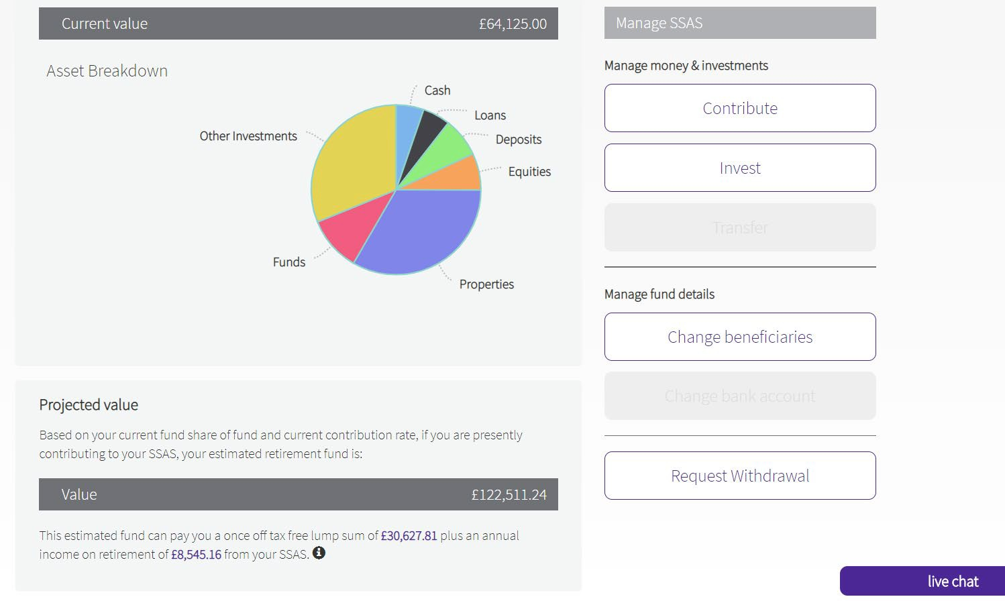

Your investments are broken down with online functionality that will appear like this. The tabs allow you to undertake certain instructions.

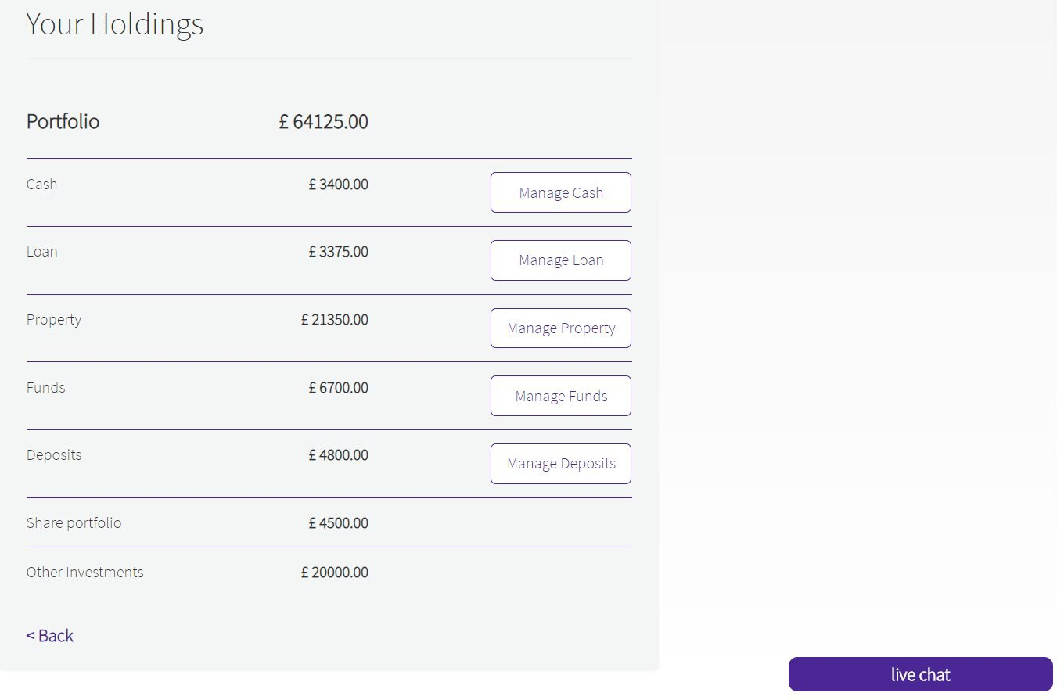

You can make a number of investments from your cash account. Investment funds can be linked into your cash trustees account. We will organise this with you once we activate your online account. We also offer an “in field” search functionality for commercial property with Zoopla.

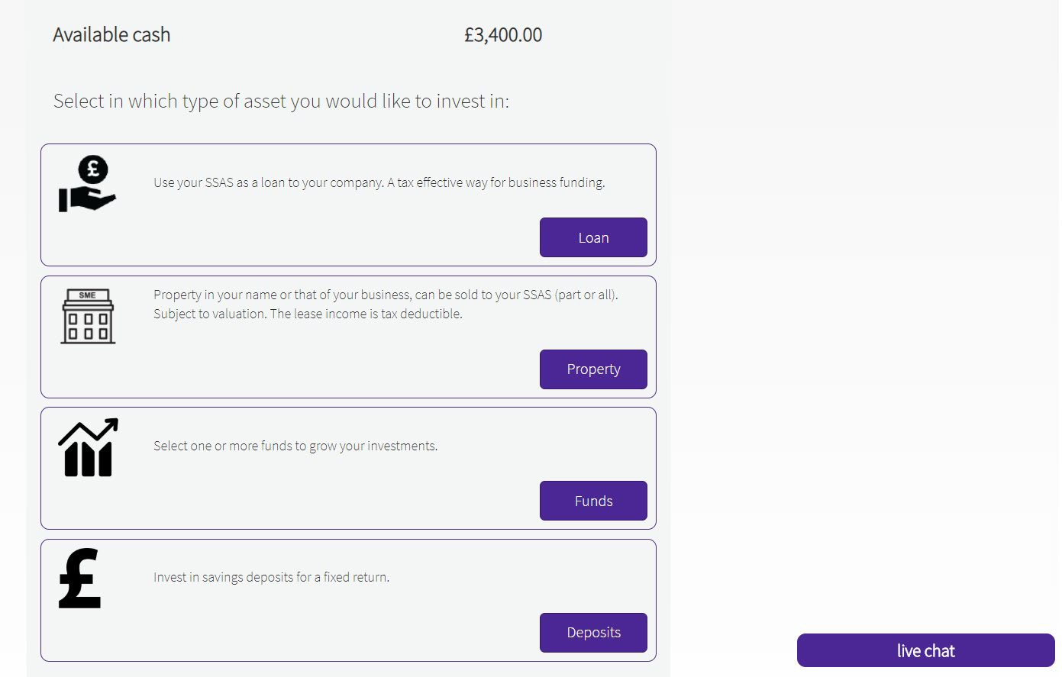

Phase 2 will integrate share trading with the end of day valuations being added to your SSAS

account through your dashboard. You can access your share dealing account by logging into your share account directly or via your dashboard.

If you are seeking to open a low cost share dealing account now, to be added to your dashboard once

phase 2 has been completed, this can be undertaken for you and your dedicated administrator can

organise this for you.

You can purchase and sell stocks and shares in the following markets and can send and receive money between your SSAS bank account and trading account in the same working day (subject to mid-day   
cut off time) via your dashboard.

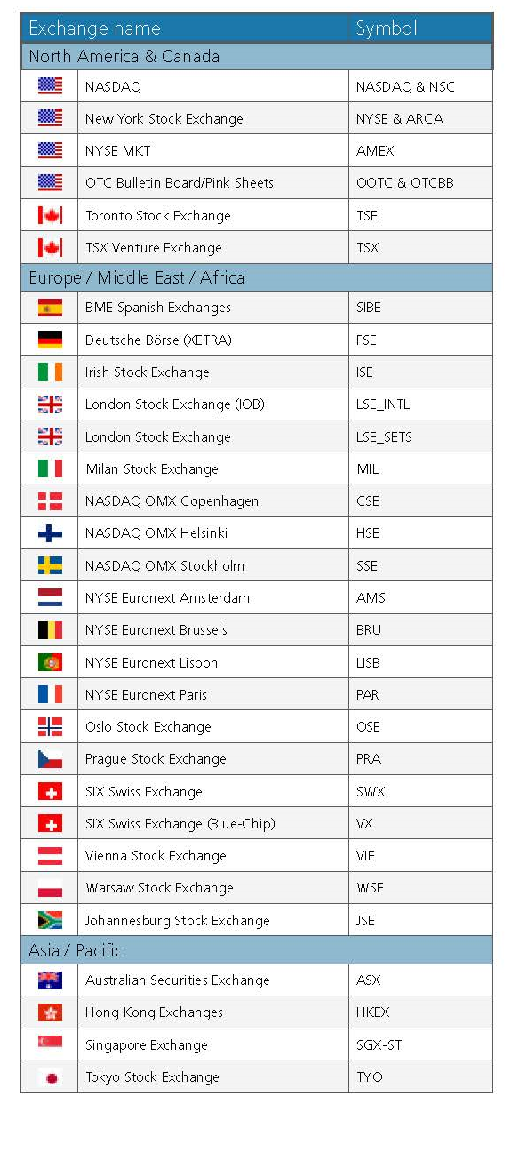

# 5. Pension Statement

**Pension income cycle for Mel Jones**

The fund can support present rates of income and can also support indexation.

The glidepath below set out the effect of current rates of pension income to the fund  
 over a twenty year cycle based on a net scheme yield of 4%.

|  |  |  |  |
| --- | --- | --- | --- |
| **Age** | **Net Change in Fund value** | **Rate of return on investments** | **Fund Value at end of the year** |
| 61 | £ 14,779.76 | 4.00% | £ 364,273.76 |
| 62 | £ 14,570.95 | 4.00% | £ 358,844.71 |
| 63 | £ 14,353.79 | 4.00% | £ 353,198.50 |
| 64 | £ 14,127.94 | 4.00% | £ 347,326.44 |
| 65 | £ 13,893.06 | 4.00% | £ 341,219.50 |
| 66 | £ 13,648.78 | 4.00% | £ 334,868.28 |
| 67 | £ 13,394.73 | 4.00% | £ 328,263.01 |
| 68 | £ 13,130.52 | 4.00% | £ 321,393.53 |
| 69 | £ 12,855.74 | 4.00% | £ 314,249.27 |
| 70 | £ 12,569.97 | 4.00% | £ 306,819.24 |
| 71 | £ 12,272.77 | 4.00% | £ 299,092.01 |
| 72 | £ 11,963.68 | 4.00% | £ 291,055.69 |
| 73 | £ 11,642.23 | 4.00% | £ 282,697.92 |
| 74 | £ 11,307.92 | 4.00% | £ 274,005.83 |
| 75 | £ 10,960.23 | 4.00% | £ 264,966.07 |
| 76 | £ 10,598.64 | 4.00% | £ 255,564.71 |
| 77 | £ 10,222.59 | 4.00% | £ 245,787.30 |
| 78 | £ 9,831.49 | 4.00% | £ 235,618.79 |
| 79 | £ 9,424.75 | 4.00% | £ 225,043.54 |
| 80 | £ 9,001.74 | 4.00% | £ 214,045.28 |
| 81 | £ 8,561.81 | 4.00% | £ 202,607.09 |
| 82 | £ 8,104.28 | 4.00% | £ 190,711.38 |
| 83 | £ 7,628.46 | 4.00% | £ 178,339.83 |
| 84 | £ 7,133.59 | 4.00% | £ 165,473.43 |
| 85 | £ 6,618.94 | 4.00% | £ 152,092.36 |

**Pension income cycle for Ewa Jones**

The fund can support present an income of £20,000 p.a. and can also support indexation

of pension income.

The glidepath below set out the effect of current rates of pension income to the fund  
 over a twenty year cycle based on a net scheme yield of 4%.

|  |  |  |  |
| --- | --- | --- | --- |
| **Age** | **Net Change in Fund value** | **Rate of return on investments** | **Fund Value at end of the year** |
| 59 | £ 15,278.48 | 4.00% | £ 377,240.48 |
| 60 | £ 15,089.62 | 4.00% | £ 372,330.10 |
| 61 | £ 14,893.20 | 4.00% | £ 367,223.30 |
| 62 | £ 14,688.93 | 4.00% | £ 361,912.24 |
| 63 | £ 14,476.49 | 4.00% | £ 356,388.72 |
| 64 | £ 14,255.55 | 4.00% | £ 350,644.27 |
| 65 | £ 14,025.77 | 4.00% | £ 344,670.04 |
| 66 | £ 13,786.80 | 4.00% | £ 338,456.85 |
| 67 | £ 13,538.27 | 4.00% | £ 331,995.12 |
| 68 | £ 13,279.80 | 4.00% | £ 325,274.93 |
| 69 | £ 13,011.00 | 4.00% | £ 318,285.92 |
| 70 | £ 12,731.44 | 4.00% | £ 311,017.36 |
| 71 | £ 12,440.69 | 4.00% | £ 303,458.05 |
| 72 | £ 12,138.32 | 4.00% | £ 295,596.38 |
| 73 | £ 11,823.86 | 4.00% | £ 287,420.23 |
| 74 | £ 11,496.81 | 4.00% | £ 278,917.04 |
| 75 | £ 11,156.68 | 4.00% | £ 270,073.72 |
| 76 | £ 10,802.95 | 4.00% | £ 260,876.67 |
| 77 | £ 10,435.07 | 4.00% | £ 251,311.74 |
| 78 | £ 10,052.47 | 4.00% | £ 241,364.21 |
| 79 | £ 9,654.57 | 4.00% | £ 231,018.77 |
| 80 | £ 9,240.75 | 4.00% | £ 220,259.53 |
| 81 | £ 8,810.38 | 4.00% | £ 209,069.91 |

**Pension Forecast Statement**

### Benefit Statement for for Mel Jones based on a project to age 65.

Your estimated retirement fund is £101,000 at your scheme retirement date. This could pay you an income of £3690 pa plus a tax free lump sum of £25200. We have made the following assumptions:

1. Investment growth is a net rate of 5%.
2. Inflation is 2.5% p.a.
3. Pension will not increase in retirement
4. The estimated annual retirement income is based on current rates.
5. No further contributions have been provided for.
6. The figures are a guide and not guaranteed. Your final pension fund and the income available will depend on factors including the growth your fund achieves, contributions you make in future, charges, inflation, your retirement age, annuity rates at the time and the annuity options you choose.
7. The lifetime allowance at an assumed rate of growth of 2.5% is not expected to affect your benefits and no planning is required at this time in respect of an excess tax charge.
8. We have not included payment of the 1st tier state pension.

**Pension Forecast Statement**

### Benefit Statement for for Eva Jones based on a projection to age 65 of uncrystallised rights.

Your estimated retirement fund is £89700 at your scheme retirement date. This could pay you an income of £3230 pa plus a tax free lump sum of £22400. We have made the following assumptions:

1. Investment growth is a net rate of 5%.
2. Inflation is 2.5% p.a.
3. Pension will not increase in retirement
4. The estimated annual retirement income is based on current rates.
5. No further contributions have been provided for.
6. The figures are a guide and not guaranteed. Your final pension fund and the income available will depend on factors including the growth your fund achieves, contributions you make in future, charges, inflation, your retirement age, annuity rates at the time and the annuity options you choose.
7. The lifetime allowance at an assumed rate of growth of 2.5% is not expected to affect your benefits and no planning is required at this time in respect of an excess tax charge.
8. We have not included payment of the 1st tier state pension.