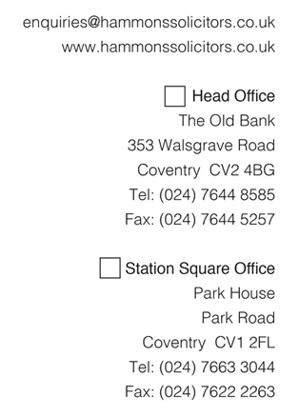

Our Ref: NG/JN/J516.16 VAT Reg. No.: GB 272 4190 66

Date: No.:

To: JVAM Ltd

Re: **Transfer of Parking Space at 2A Shieldhall Street**

|  |  |  |  |  |
| --- | --- | --- | --- | --- |
|  | Costs | Disbs | **%** | VAT |
| **To legal costs** in connection with your transfer of the above property and to the supply of legal services in connection therewith; including all telephone calls, letters and general attendances on your behalf throughout.  Bank Administration Fee | £500.00  £35.00 |  | 20%  20% | £100.00  £7.00 |
| **Disbursements**  HM Land Registry Official Search  HM Land Registry Bankruptcy Search  HM Land Registration Fee |  | £3.00  £2.00  £20.00 |  |  |
|  | £535.00 | £25.00 | 20% | £107.00 |
| **TOTAL** | £667.00 |  |  |  |