**AUTHORISED SIGNATORY LIST FOR RC ADMINISTRATION LTD**

It is hereby resolved that the people whose details appear below are authorised to sign on behalf of RC Administration Limited for the purpose of approving and co-signing any instructions issued to a bank or a building society by scheme Trustee(s). This is applicable to all pension scheme bank accounts that RC Administration Ltd is a co-signatory to.

The number of required signatures on behalf of RC Administration Ltd is one.

**NAME** **SIGNATURE**

DAVID NICKLIN

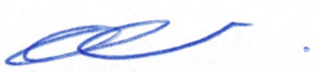

ESTHER SALMON

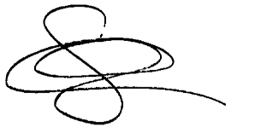

STACY LUNNON



EMILY MCALISTER

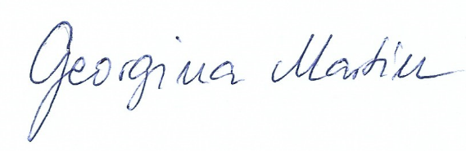

GEORGINA MARTIN

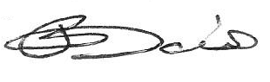

PAUL DAVIES

Confirmed by the current Director of RC Administration Ltd

DAVID NICKLIN   
DIRECTOR